**I Went Walking “Little Book”**

* **Make 1 little book per student:**
  + **Staple the front cover, 6 blank pages, and the last page**

C:\Users\jkirklan\AppData\Local\Microsoft\Windows\Temporary Internet Files\Content.IE5\V8Z0B944\MC900281620[1].wmf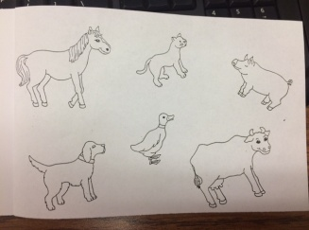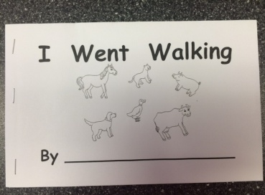

* **To make each page, begin with the first character in the book (black cat) and continue through all of the characters.**
  + 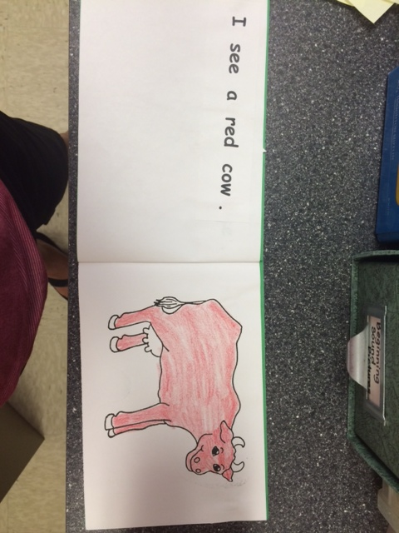**Glue the WORDS on the left and the PICTURE on the right** *(RF.K.1.a Demonstrate understanding of the basic features of print/follow words from left to right)*
  + **Read words with 1 to 1 correspondence** *(RF.K.1.a & b Follow words from left to right/understand that words are separated by spaces in print)*