Unit 1 Week 4 Shared Reading Daily Lesson Focus
MATERIALS | Brown Bear, Brown Bear, What Do You See? by Bill Martin, Jr. and Eric Carle  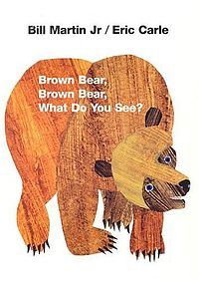
DAY | FOCUS
MONDAY | Picture Walk – Answering Questions
TUESDAY | Page-by-Page Progression, Spaces in Print
WEDNESDAY | Left-to-Right and Top-to-Bottom Progression
THURSDAY | One-to-One Letter/Sound Correspondences
FRIDAY | Begin creating a little book, “Brown Bear, Brown Bear, What Do You See?”
Grade Kindergarten Date________________

