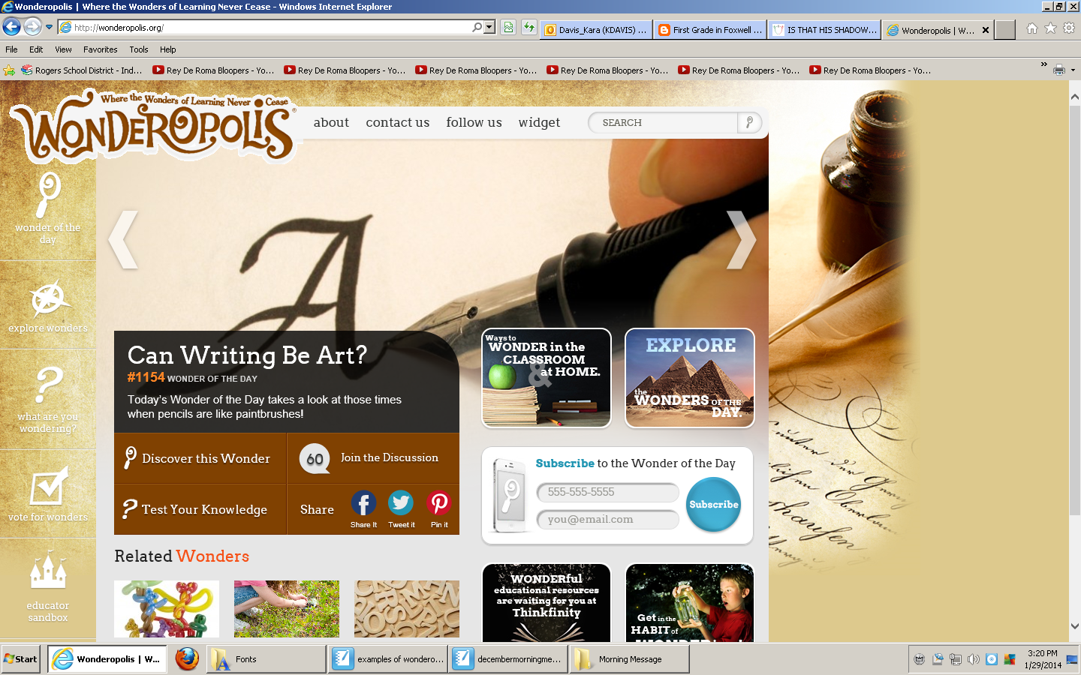

Search for topics here

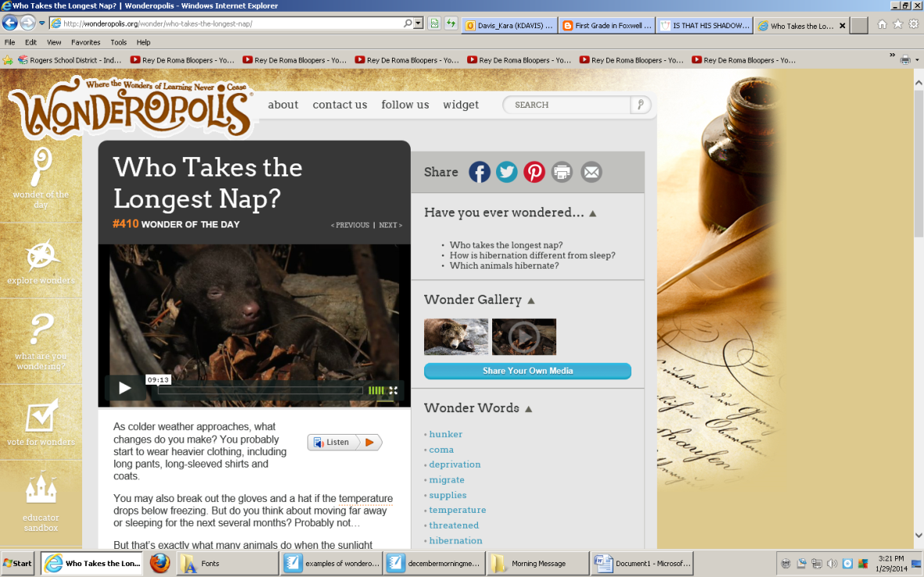

Pull pictures from here, just right click, copy, and paste into smartboard