Story Books

books that have made-up stories about

people, animals, or things

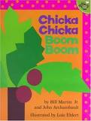 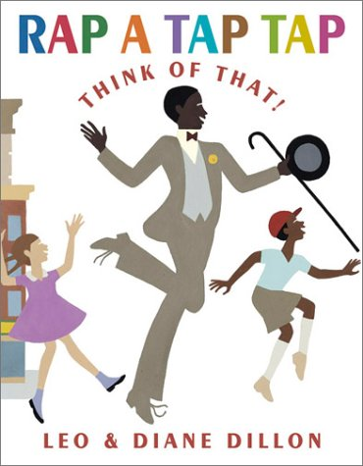

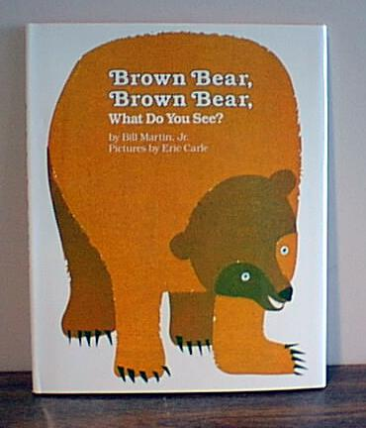

Poems

A few lines of writing that have rhythm and rhyme

C:\Documents and Settings\st\Local Settings\Temporary Internet Files\Content.IE5\GREFDJRN\MC900438203[1].wmf

Twinkle, Twinkle Little Star

Twinkle, twinkle, little star,  
How I wonder what you are.   
Up above the world so high,  
Like a diamond in the sky.  
Twinkle, twinkle, little star,  
How I wonder what you are!

C:\Documents and Settings\st\Local Settings\Temporary Internet Files\Content.IE5\3K9UBNKY\MC900390834[1].wmf

Jack and Jill

Jack and Jill went up the hill

To fetch a pail of water.

Jack fell down and broke his [crown](http://en.wikipedia.org/wiki/Crown_(anatomy)),

And Jill came tumbling after.

Information Books

books that have information about real things

