Goal: I can write the letter X. I can brainstorm words that begin with the letter X.



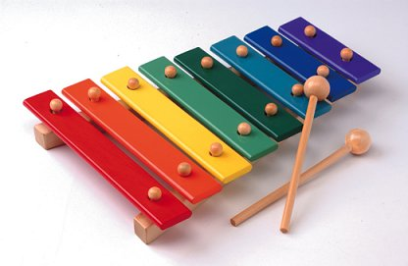 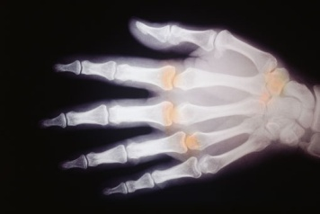

X __ _   
x ____