Kindergarten Name: _________________

Informational

Dogs are animals that people keep as pets.  They have four legs.  Their body is covered in fur.  Some dogs play fetch with a ball or a stick.  A baby dog is called a puppy.  Would you like to have a dog at your house?

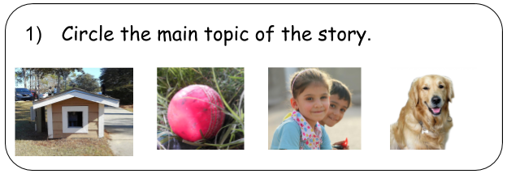

In the sky, you can see the sun, stars, and the moon.  The sun is up during the day.  The sun gives us light and heat. Plants need the sun to grow.  We can see the stars at night. There are more stars than we can count.  The moon is out at night. Sometimes we can still see it during the day! It does not give off light and heat.  What can you see in the sky?

