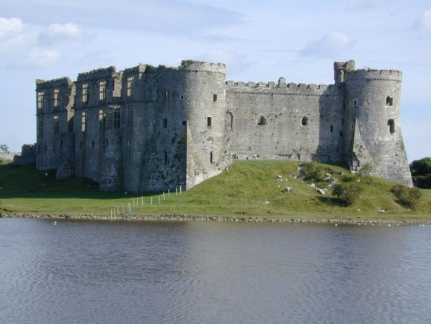

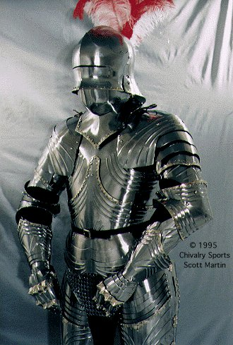

Fact Tracker

__

**What:**

_______________

__________________________

__________________________

**When:**

__________________________________

**Where:**

_________________________________

____________________________

**The author says the Middle Ages were a time of great change in Europe. What reasons and evidence listed in the text do they use to explain that point**.RI.4.8 Page 14

____________________________

____________________________________________ ____________________________________________

____________________________________________

_____________________________

__________________________________________________________________________________________

List the Feudal System Hierarchy

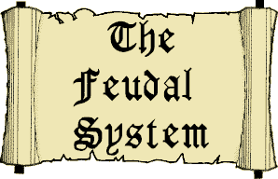_________________

_________________

_________________

_________________

**Was The Feudal System is the Middle Ages fair to all people?** **Provide evidence from the text to support your answer.(RI.4.1)(pages 15-19)**

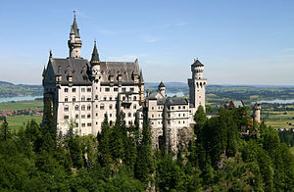**_________________________________________________________________________________________________________________________________________________________________________________________________________________________________________________________________________________________________________________________________________________________________________________________________________________________________________________________ ____________________________________________________________________________________________________________________________________________________**

**Purpose**

**________________________________________________________________________________________________________________________________________________________________________________________**

**Where**

**When**

Pages 22-36 **Castles**

Explain how the building of castles changed over time. Provide evidence from the text to support your answer. ___________________________________________________________________________________________________________________________________________________________________________________________________________________________________________________________________________________________________________________________________

Which castle would you want to live in, the first castles or the stone castles? Why?___________________________________________________________________________________________________________________________________________________________________________________________________________________

**Castle Life** (pages 41-51)

If you lived in The Middle Ages in a castle, who would you want to be? (a lord, lady, child, servant, cook, jester) Provide evidence from the text to support your answer.

_________________________________________________________________________________________________________________________________________________________________________________________________________________________________________________________________________________________________________________________________________________________________________________________________________________________________________________________

**Steps to Knighthood**(pg. 63-69)

**1_________________________________________________________________________________________________**

**2_________________________________________________________________________________________________**

**3_________________________________________________________________________________________________**

**Armor /Weapons (pg.75-91**

**Helmets**

**___________________________________________________________________________________________________**

**Hauberk/Mail**

**___________________________________________________________________________________________________**

**Swords**

**___________________________________________________________________________________________________**

**Coats of Arms**

**___________________________________________________________________________________________________**

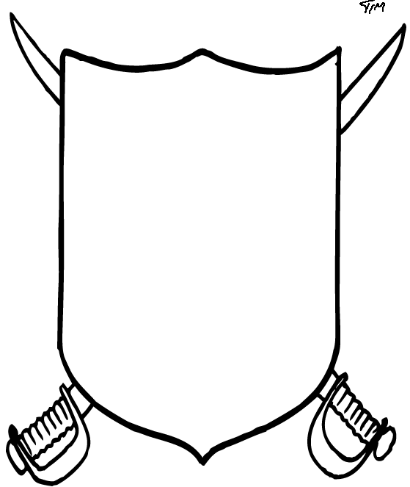

Design your own

coat of arms.