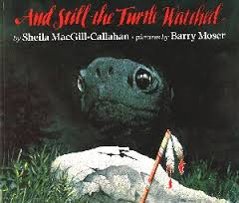

**Close Reading**

**And Still the Turtle Watched by Sheila MacGill-Callahan**

***Read 1***

1. How was the turtle created?
2. Why did the old man and the boy create the turtle?
3. Who is Manitou?
4. Why did the turtle grow very sad?
5. Why did the children leave? What evidence from page 12 and the illustration proves why they left?
6. On page 17, what happened to turtle?
7. What was the man looking for?



**Close Reading**

**And Still the Turtle Watched by Sheila MacGill-Callahan**

***Read 2***

1. What does the author mean by, “The Great Bear chased the Little Bear around and around the Northern sky”?
2. Tell the meaning of this sentence:

“He heard strangle growling noises still the songs of birds.”

1. Reread page 19. Tell about the condition of the rock. What words does the author use to describe the rock?
2. On page 19, why did the author say the man was able to see the turtle on the rock?
3. Use context clues to determine what the word “hoisted” means.



**Close Reading**

**And Still the Turtle Watched by Sheila MacGill-Callahan**

***Read 3***

1. The Native American children come to the turtle in the beginning of the story. How do the strangers interact with the turtle? Use evidence from the story to support your answer.
2. Compare and contrast the turtle’s environment from the beginning of the story and the end of the story.
3. What is the theme or lesson of this story?
4. How does the title, “*And Still the Turtle Watched*” relate to the story?