Name: _____________________________
Native American Story Matrix
 |  | 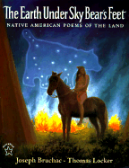  “The Scattered Stars” | 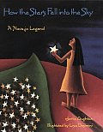 | 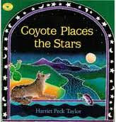
What does the story explain?

Characters

Events

Theme

Name: ___________________________________
Native American Story Matrix
Directions: Using the information from the matrix, answer these questions.

Compare the themes of “The Scattered Stars” and How the Stars Fell into the Sky. How are the themes the same and different?

Looking at the events in each of the stories, are there any patterns? What would explain this?

