*The Orion Story*

By, H.A. Rey

Excerpt from Find the Constellations

Orion was a great hunter who roamed the earth with his two companions, the Big Dog and the Little Dog. Unfortunately, Orion was also a great **braggart.** He used to boast that no game could ever escape him. This annoyed the goddess Juno, so one day while Orion was pursuing a hare, she had a scorpion sting his heel and Orion dies.

Now there was a physician, Aesculapius, the most famous doctor of all times. Supposedly he got some of his medical secrets from the snakes; and he usually carried one around. Aesculapius was called and Lo! He brought Orion back to life!

But this was not the end. The god Pluto, Kind of the Dead, heard the news and got worried. What would become of his kingdom if the dead could be awakened by doctors? So he told his brother Jupiter, about the case, and Jupiter promptly threw his thunderbolt and killed Orion, this time for good, and Aesculapius, too.

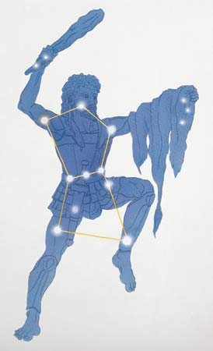 After that, everybody concerned was put into the sky among the stars: Orion with his two dogs, Aesculapius and his pet serpent, the Scorpion, and also the hare Orion had been hunting when he had the accident. As a precaution, the Archer was posted near the Scorpion, and Orion and the Scorpion were placed in opposite parts of the sky so they could never again get into trouble. Orion shines in winter, the Scorpion in summer, and when one rises the other sets, to this very day.



**Orion**

**Scorpion**

1. The text says thatAesculapius was a famous doctor. Why was he considered a famous doctor? How did his ability to help others end up hurting himself?
2. Why were Orion and Scorpion placed in opposite sides of the sky?
3. In the first paragraph, the word **braggar**t is in bold print. The next sentence reads: *He used to boast that no game could ever escape him*. What do you think it means to be a braggart?

L Jones 2013