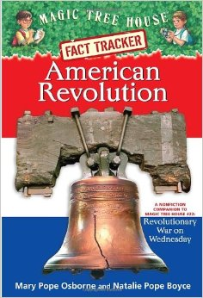American Revolution

Fast Tracker: Chapter 2

Writing Task

The life of the colonists was not always easy. What things made the colonists’ lives hard? Use evidence from chapter 2 to support your opinion.

______________________________________________________________________________________________________________________________________________________________________________________________________________________________________________________________________________________________________________________________________________________________________________________________________________________________________________________________________________________________________________________________________________________________________________________________________________________________________________________________________________________________________________________________________________________________________________________________________________________________________________________________________________________________________________________________________________________________________________________________________________________________________________________________________________________________________________________________________________________________________________________________________________________________________________________________________________________________________

Opinion Writing Plans: Week of January 19

*Give students opportunities to reread Chapter 2 during the week.

Monday: District PD

Tuesday:

*Teacher reads pages 1 – 20 aloud.

*Introduce the prompt.

*Students read Chapter 2

pages 21 -36.

*Students take notes???

Wednesday:

*Review writing an introduction and stating your opinion. (Review/Add to anchor charts.)

*Students write the introduction and state their opinions.

Thursday:

*Review writing big ideas and details.

(Review/Add to anchor charts.)

*Students write Big Idea 1 and two details.

Friday:

*Review writing big ideas and details.

(Review/Add to anchor charts.)

*Stuents write Big Idea 2 and two details.

Monday:

*Review writing big ideas and details.

(Review/Add to anchor charts.)

*Students write Big Idea 3 and two details.

Tuesday:

*Review writing conclusions.

(Review/Add to anchor charts.)

*Students write their conclusions.

Wednesday - Friday

*Revise/Edit

*Type