Note about the word list-

As I was reading the story for the first time, I jotted down this list of words that I thought students might struggle with. Most are Tier II words, and will require some explicit teaching of the meaning and use. Occasionally I thought there was enough information in the text for the students to figure out the meaning and I noted that with the words context clues in parenthesis. A few words made the list twice and are noted with an asterisk.

The definitions came from my favorite source for kid-friendly definitions:

<http://nhd.heinle.com/Home.aspx>

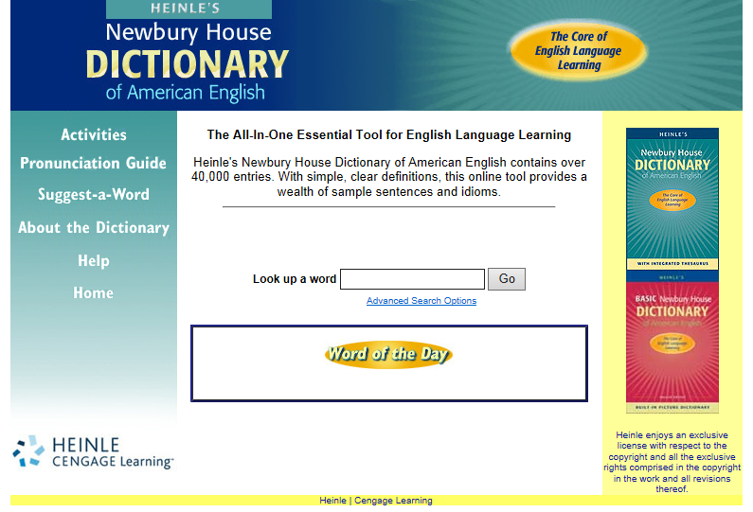

This list is by no means an extensive list, but the words would provide opportunities for students to engage in performance of the following standards:

**L.4.4.a** Use context clues (e.g., definitions, examples, or restatement in text) as clues to the meaning of a word or phrase

**L.4.4.c** Consult reference materials (e.g., dictionaries, glossaries thesauruses), both print and digital, to find the pronunciation and determine or clarify the precise meaning of key words and phrases

**RL.4.4** Use the meaning of words and phrase as they are used in a text, including those that allude to significant characters found in mythology (e.g., Herculean)

**L.4.5.c** Demonstrate understanding of words by relating them to their opposites (antonyms) and to words with similar but not identical meanings (synonyms).

**L.4.6** Acquire and use accurately grade-appropriate general academic and domain specific words and phrases, including those that signal precise **actions, emotions**, or **states of being** (e.g., quizzed, whined, stammered) and that are **basic to a particular topic** (e.g., wildlife conservation, and endangered when discussing animal preservation)

Here are a few graphic organizers that would apply to this book and the 4th grade standards.

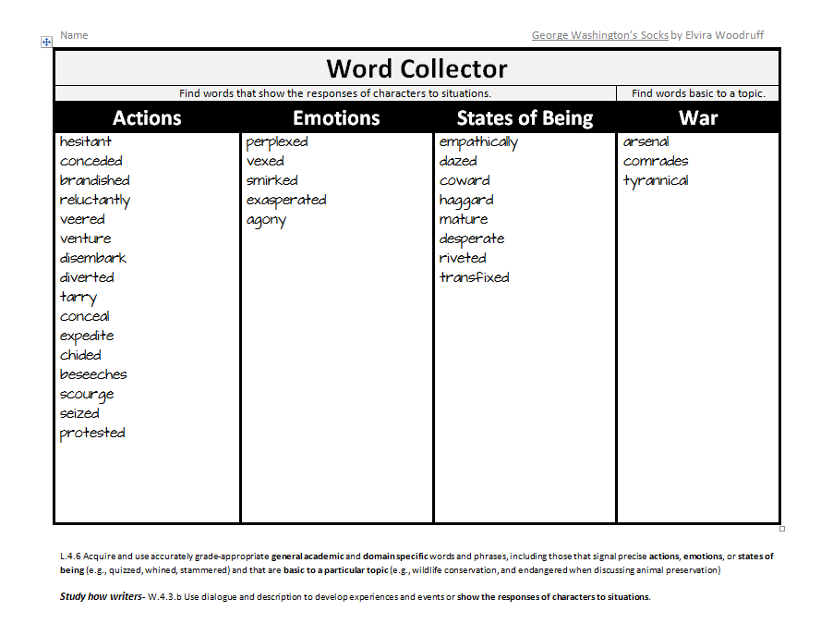

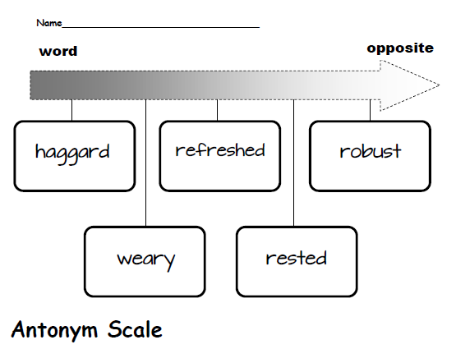

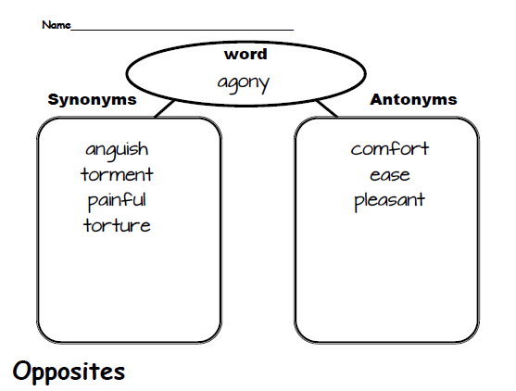

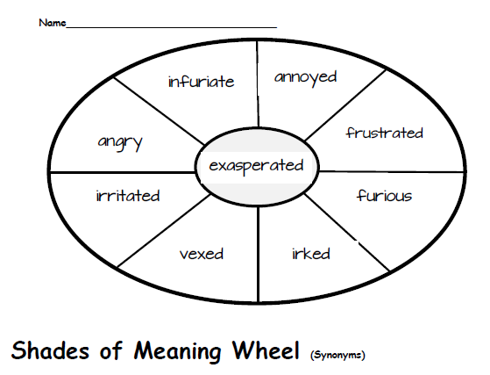

The last 3 would provide opportunities to engage students with **L.4.4.c** (consult reference materials).