Featured Word: **REVOLUTION**

**Part 1**

**Teaching Individual Words**

**Definition:**

* the usually violent attempt by many people to end the rule of one government and start a new one
* a sudden, extreme, or complete change in the way people live, work, etc.
* the action of moving around something in a path that is similar to a circle

**Provide an Explanation:**

Define/ explain the word.

Lead into a discussion of what this event in history might be about.

**Part 2**

**Generative Word Study**

**Identify related words:**  revolve

revolution**ary**

revolution**ist**

revolution**ize**

*NOTE: When we lead students to notice the generative aspect of words, we are helping them to understand another important (and critical) understanding about words: words related in meaning are even related in spelling. This is true even in the case of spelling changes.* (Templeton, 2010)

**Teach or Reinforce** (through discovery and direct instruction):

* The meaning of the suffixes

**Suffixes:**

-*ary* (noun) *relating to, place where*

-*ist* (noun- person) *one who*

-*ize* (verb) *make*

* How suffixes determine the part of speech
* How knowing the meaning of the suffix can give you clues to the meaning of new words

**Extend**

Identify or generate words with the suffixes *-ist*, *-ism*

-*ist* (noun- person) *one who*

*artist*

*colonist*

*dentist*

*hypnotist*

*scientist*

*tourist*

-*ize* (verb) *make*

*memorize*

*apologize*

*colonize*

*criticize*

*italicize*

*socialize*

*realize*

*organize*

*NOTE: The suffixes -ist, -ize, -ism are related and are often added to the same base elements. Ex: hypnotist, hypnotism, hypnotize.* (Henry, 2010)

*NOTE: The teaching of the Latin root volve meaning “to roll” is not recommended at this time. It is a root most frequently taught in middle school or later*. (Padak, 2008).

**Brainstorm** **Words** (throughout the unit) that can be connected to the Revolution: *boycott, violence, war, angry, unfair, hate, rebellion,* *etc.*

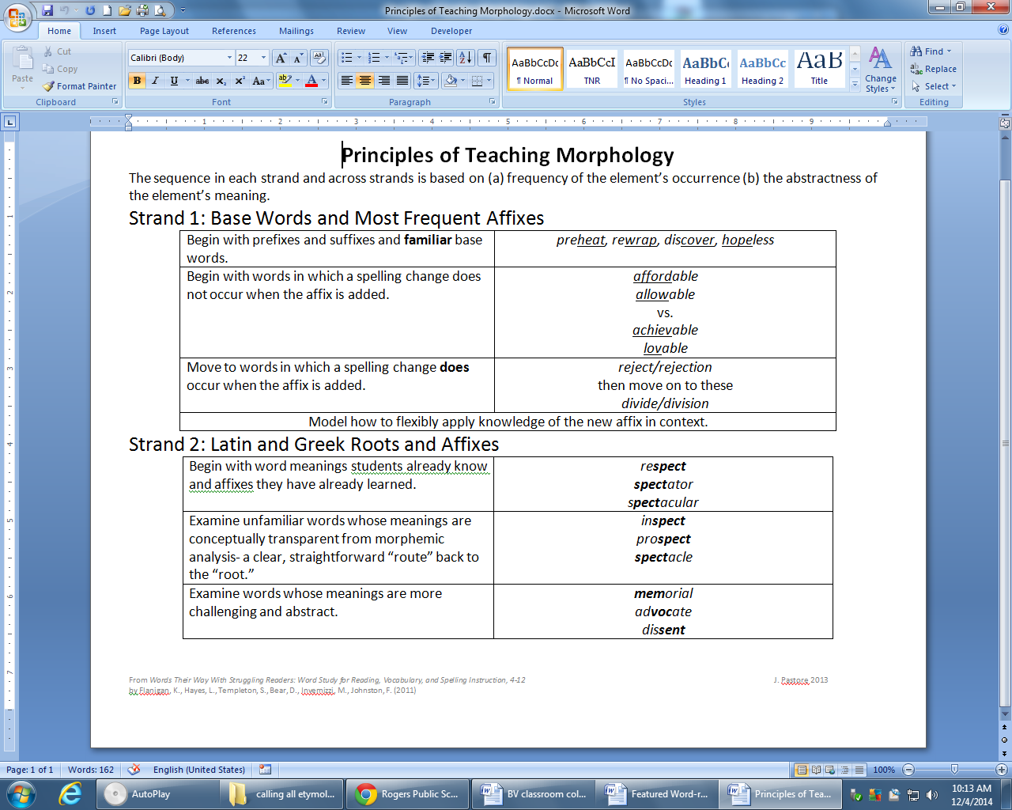**Generative Word Study and Working With Affixes and Roots**