How-To: Interactive Time Line

<http://www.brainpop.com/educators/community/lesson-plan/american-revolution-timeline-lesson-plan/?bp-topic=causes-of-the-american-revolution>

-This link takes you to a time line that is already filled in with things from the Revolutionary War.

-You can use the time line for ideas of what to include on the time line with your students OR you can show it to your students.

<http://www.readwritethink.org/classroom-resources/student-interactives/timeline-30007.html>

* This link is what you can use to make interactive time lines with your students.
* When you get to this page, click on the picture of the time line
* Students can create their own time line and save them in their documents
* When you return to edit them, students will click on the “open” folder. Their saved time lines will open up and they will be able to edit them.

**Creating the QR Codes!**

-As always, this is an optional add on but it is very engaging for the students! The students will pick one of the events or people related to an event that has been placed on your interactive time lines and the will research and report on the topic.

-Using the iPad, students will go to the “Puppet Edu” App. In this app, students can select several pictures (they can save related pictures to the ipad camera roll before beginning) and they will create an audio recording or what they researched. The recordings can be edited per every picture! I would only allow 1-2 pictures for each student.

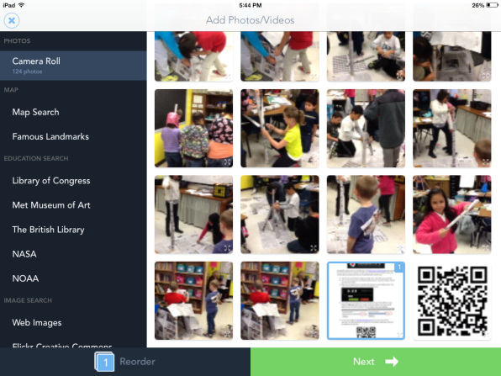

**Select Photos and push NEXT

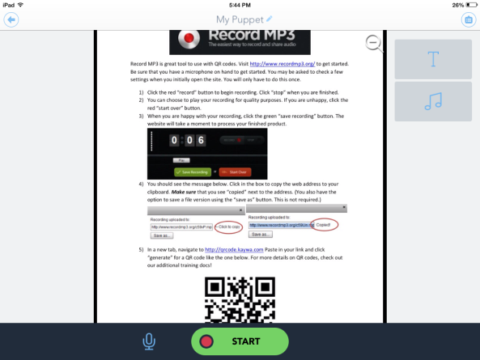

**Click “Start” to begin recording. If students mess up, they can start over on individual pictures.

-After completing their report, students will select “save” and then copy their link.

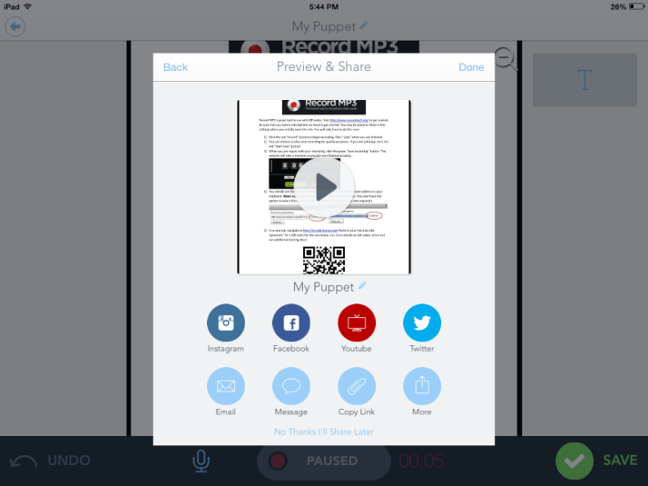

**Once the recording is complete, students can push “Save” and select the “Copy Link” circle.

-Then students will go to the App “QRAFTER” and click on “create code”.

-Then select URL and push paste.

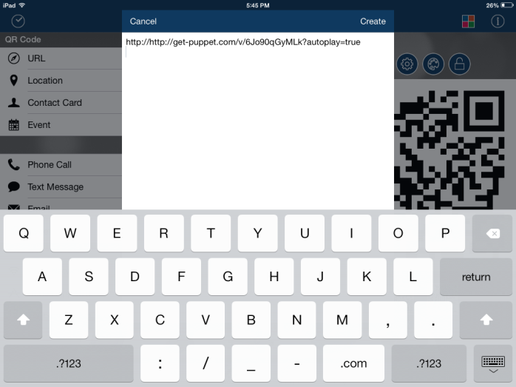

-The code will show up on the right side of the iPad screen. From there, you can select to email the code or to print the code. If your iPad is directly linked to a printer, it is better to print here. If not, have students send it to your email and print from there!

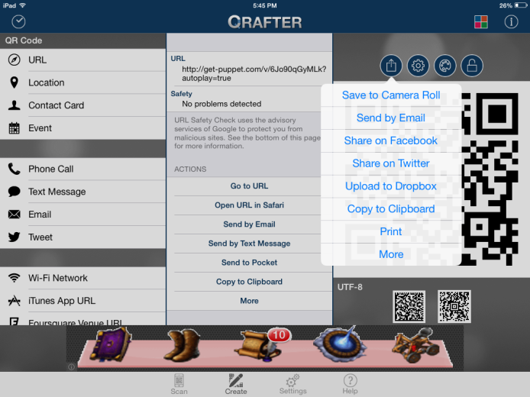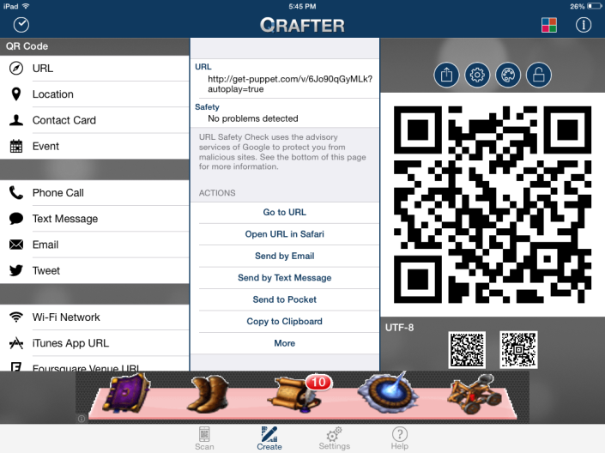

-Take the completed QR codes and place them on a HUGE time line on the wall in your classroom (or in the hallway if you are like me and do not have room)

-Students will then be able to use the “QRAFTER” app to scan the QR codes and listen to their peers report on information related to that event on the time line!

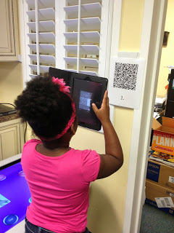

Advice:

-Set aside one afternoon to do the recordings…I would not want to mess with saving and editing. This should be the final step in the student’s research!

-If possible, plug head phones in to the iPads when students are walking through…all the QR code noise will be too loud if you let it play out loud.