Reading level - 2.5

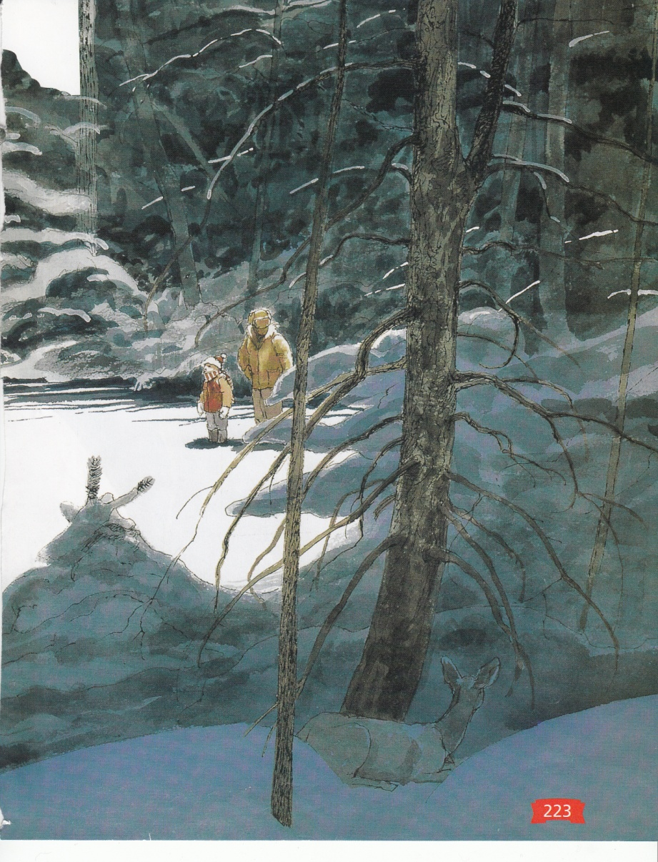**Owl Moon**

**(excerpt)**

By Jane Yolen

We went into the woods.

The shadows

were the blackest things

I had ever seen.

They stained the white snow.

My mouth felt furry,

for the scarf over it

was wet and warm.

I didn’t ask

what kind of things

hide behind black trees

in the middle of the night.

When you go owling you have to be brave.

Then we came to a clearing

in the dark woods.

The moon was high above us.

It seemed to fit exactly over the center of the clearing

and the snow below it

was whiter than the milk

in a cereal bowl.

I sighed

and Pa help up his hand

at the sound.

I put my mittens

over the scarf

over my mouth

and listened hard.

And then Pa called:

*“Whoo-whoo-who-who-who- whooooooo.*

*Whoo-whoo-who-who-who-whoooooooo.”*

I listened

and looked so hard

my ears hurt

and my eyes got cloudy

with the cold.

Pa raised his face

to call out again,

but before he could open his mouth

an echo

came threading its way

through the trees.

*“Whoo-whoo-who-who-who- whooooooo.”*

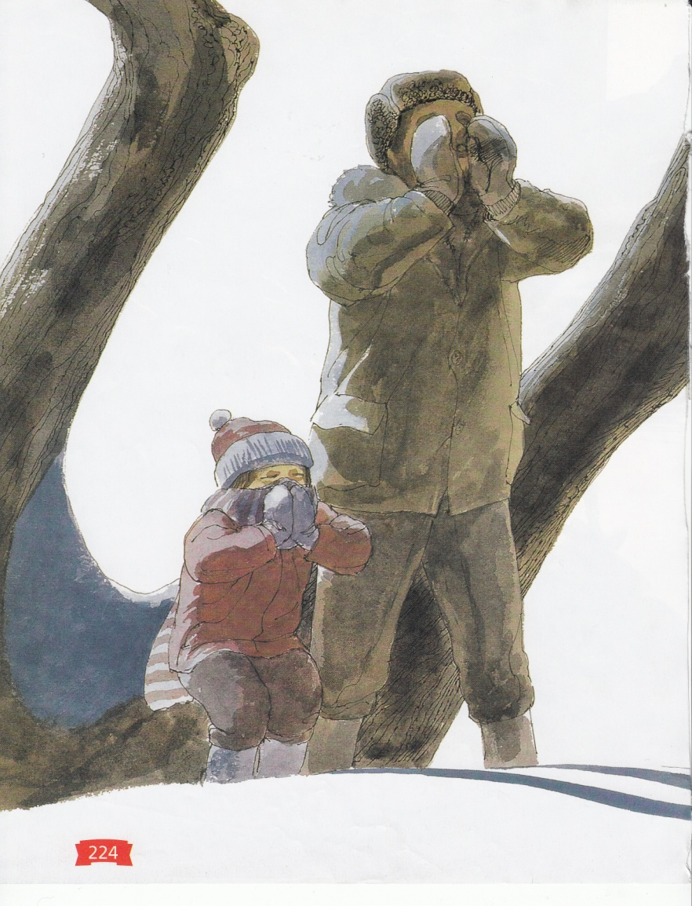

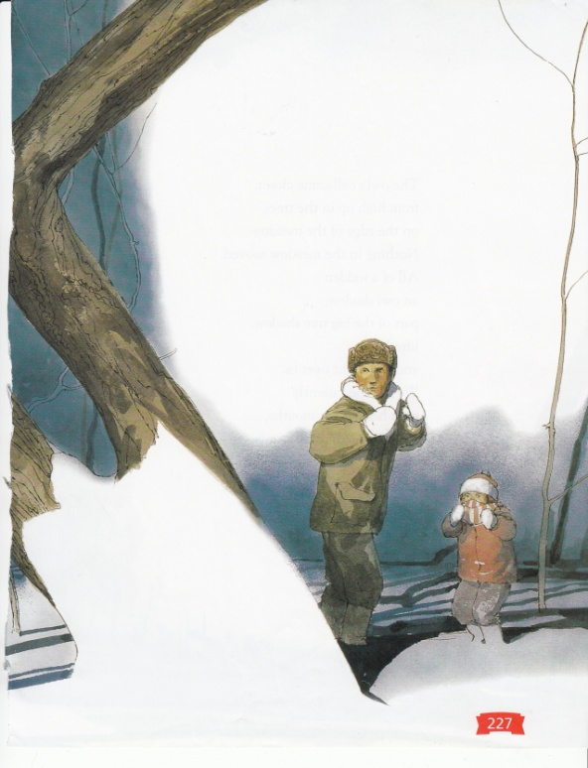

Pa almost smiled.

Then he called back:

*“Whoo-whoo-who-who-who- whooooooo.”*

just as if he

and the owl

were talking about supper

or about the woods

or the moon

or the cold.

I took my mitten

off the scarf

off my mouth,

and almost smiled too.

The owl’s call came closer,

from high up in the trees

on the edge of the meadow.

Nothing in the meadow moved.

All of a sudden

an owl shadow,

part of the big tree shadow,

lifted off

and flew right over us.

We watched silently

with heat in our mouths,

the heat of all those words

We had not spoken.

The Shadow hooted again.

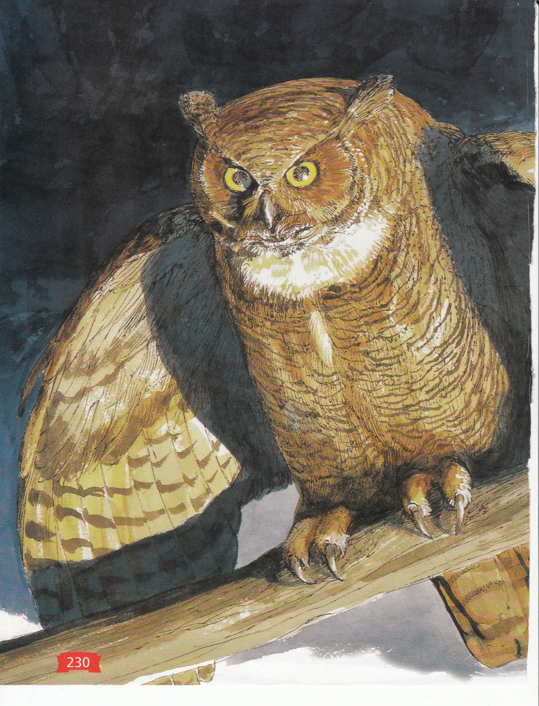

Pa turned on

his big flashlight

and caught the owl

just as it was landing

on a branch.

For one minute

three minutes,

maybe even a hundred minutes,

we stared at one another.

Then the owl

pumped its great wings

and lifted off the branch

like a shadow

without a sound.

It flew back into the forest.

“Time to go home,”

Pa said to me.

I knew then I could talk,

I could even laugh out loud.

But I was a shadow

as we walked home.

What does the word “pumped” mean as it is used in the passage?

Which of the phrases from the passage best helps the reader understand the meaning of “pumped”?

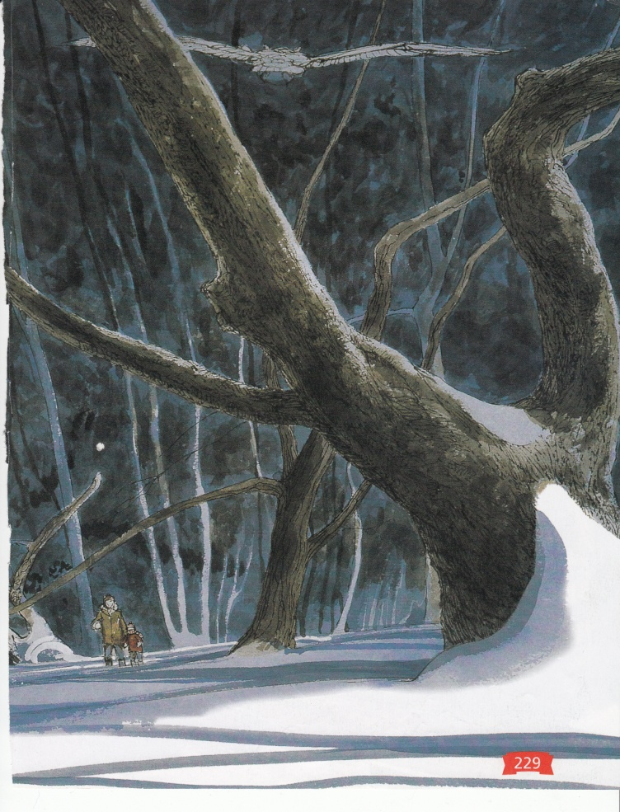

Choose one word that describes the daughter based on evidence from the text.

reckless

patient

observant

cruel

Find a sentence in the passage that supports your response.

**In this story, Jane Yolen describes a young girl’s first owling experience. Think about how the author describes the way the girl and her father move through the forest.**

**Write an original story describing the same experience from the owl’s point of view.**

________________________________________________________________________________________________________________________________________________________________________________________________________________________________________________________________________________________________________________________________________________________________________________________________________________________________________________________________________________________________________________________________________________________________________________________________________________________________________________________________________________

______________________________________________________________________________________________________________________________________________________________________________________________________________________________________________________________________________________________________________________________________________________________________________________________________________________________________________________________________________________________________________________________________________________________________________________________________________________________________________________________________________________________________________________________________________________________________________________________________________________________________________________________________________________________________________________________________