Cumulus clouds are puffy and look like cauliflowers. [](http://www.google.com/url?sa=i&rct=j&q=&esrc=s&frm=1&source=images&cd=&cad=rja&docid=W0VRR8EB8TA7MM&tbnid=A-8X7tz6N0_-tM:&ved=0CAUQjRw&url=http://samsdabblers.com/?p=301&ei=sTJTUoTyGYyI9QSH7IDoAw&bvm=bv.53760139,d.cGE&psig=AFQjCNESFXxXo10ewh22b3FSfkGCv3Ke-A&ust=1381270538096948)They also have flat bottoms. They are always changing shape and are low down in the sky.

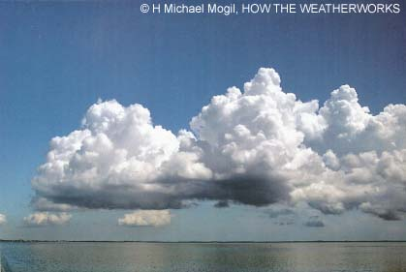 a cumulous cloud

Main Idea: ____________________________________________

Details:

1. _________________________________________________
2. _________________________________________________
3. _________________________________________________

A summary in your own words:

_____________________________________________________

_____________________________________________________

_____________________________________________________