**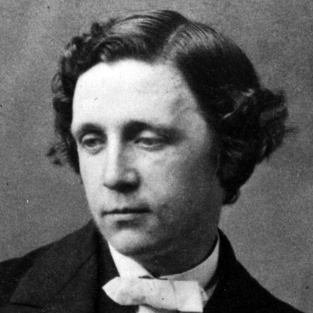Here are some interesting facts about Lewis Carroll, the author of *Alice in Wonderland*.**

* Lewis Carroll’s real name is Charles Dodgson. He used the name Lewis Carroll when he was writing his children’s books and composing his poems.
* He was born in 1832 and died in 1898.
* Lewis Carroll was a teacher of maths at Oxford University.
* Lewis Carroll was one of eleven children. When he was growing up, he often spent time playing literary games with his brothers and sisters.
* He was also very keen on drawing as a child.
* Lewis Carroll often used to take the three daughters of his friend, Dean Liddell, for days out and boat trips on the river. It was on one of these trips that he first told the story that became *Alice in Wonderland*. The story was first published in 1865.
* Carroll wrote another Alice book. This one was called *Alice Through the Looking Glass* and it was published in 1865.
* As well as writing children’s books, Lewis Carroll also enjoyed writing poetry, and he was a keen letter writer.
* Lewis Carroll produced several works about mathematics when he was working at Oxford University, and he invented the Carroll Diagram (sometimes known as the Lewis Carroll Square), a method of grouping data which is still taught in maths lessons to today.
* Lewis Carroll loved puzzles and games. He was a very keen chess player, and there are lots of references to chess (and other games) in his books for children.