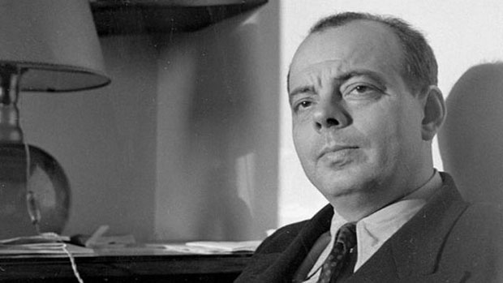Antoine De Saint-Exupéry

Antoine de saint Exupery was born on 29th June, 1900 in Marseille, France. His father died in 1904 due to a stroke. His mother moved her children across France to Le Mans in 1909. He grew up in the castle of Saint-Maurice-de-Rémens, surrounded by sisters, aunts, cousins and nurses. He attended religious schools, and a Catholic boarding school in Switzerland (1915-1917).

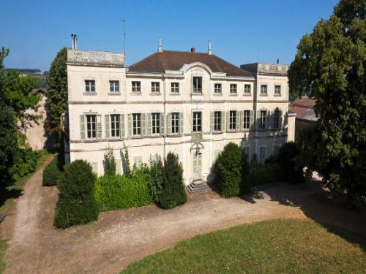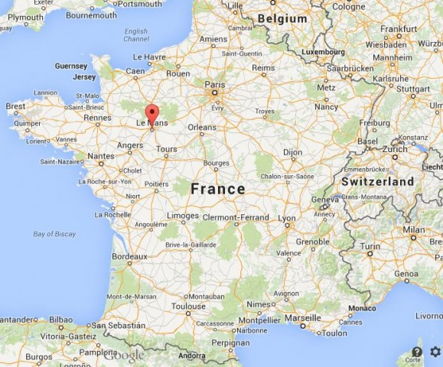

Saint-Maurice-de-Rémens

After he failed to pass the entrance exams for the French Naval Academy, he enrolled himself in art school to study architecture. In 1921, he started off as a mechanic and joined the French Air Force to become a pilot. When his fiancé’s family objected, he settled in Paris where he took an office job and started to write. His engagement broke off some time later.

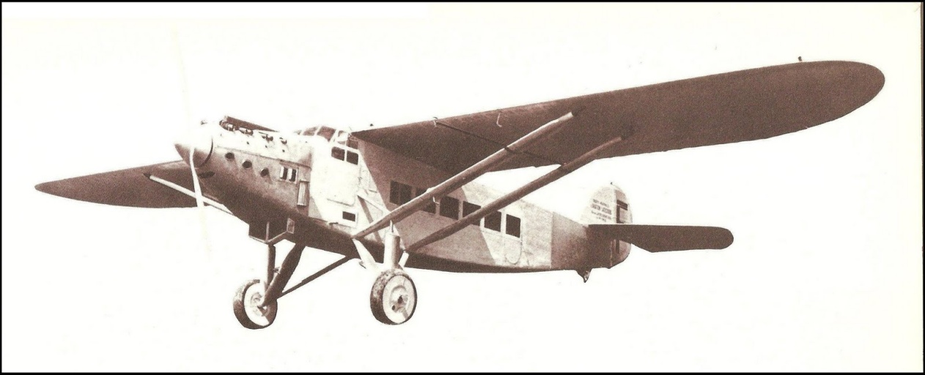Saint-Exupéry’s career took off in 1926. He returned to flying and became a pilot for *Aeropostale*, a pioneering aviation company that transported mail from France to Africa.

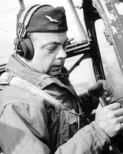

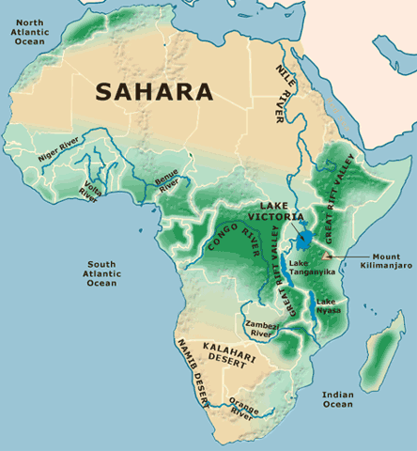In 1927, he became the director of a secluded airfield in the Sahara Desert called Cape Juby. During this period, he lived in a wooden shack and he slept on a thin straw mattress. "I have never loved my house more than when I lived in the desert," he recalled. This was where he developed his love for the desert which was reflected in several of his books including *The Little Prince*.

Saint-Exupéry continued flying for the rest of his life. He survived several plane crashes including one in the Libyan Desert where he and his copilot spent three days walking to safety. He disappeared on a reconnaissance flight over the Mediterranean and France in July 1944 and is believed to have died at that time.

Adapted from:

<http://www.famousauthors.org/antoine-de-saint-exupery>

<https://kachlynda.wordpress.com/2011/02/09/a-pilot-and-a-little-prince/>

<http://www.trussel.com/saint-ex/stamps/chad84.htm>