From Chapter 1 of Lewis Carroll’s

*Alice’s Adventures in Wonderland*

Alice was beginning to get very tired of sitting by her sister on the bank, and of having nothing to do: once or twice she had peeped into the book her sister was reading, but it had no pictures or conversations in it, ‘and what is the use of a book,’ thought Alice ‘without pictures or conversation?’

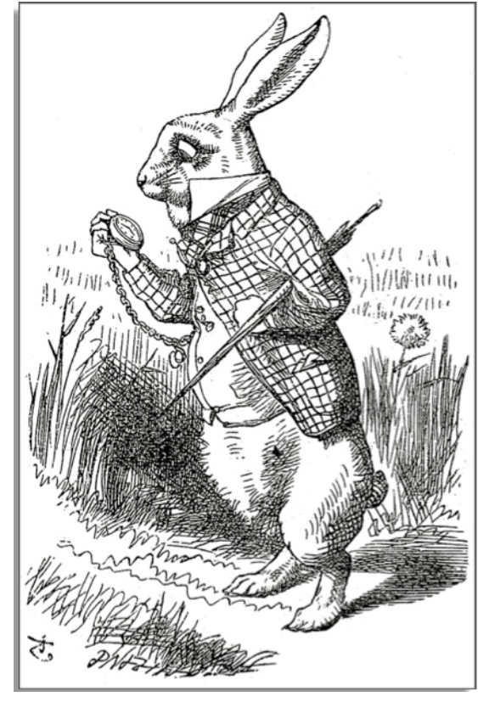

So she was considering in her own mind (as well as she could, for the hot day made her feel very sleepy and stupid), whether the pleasure of making a daisy-chain would be worth the trouble of getting up and picking the daisies, when suddenly a White Rabbit with pink eyes ran close by her.

There was nothing so VERY remarkable in that; nor did Alice think it so VERY much out of the way to hear the Rabbit say to itself, ‘Oh dear! Oh dear! I shall be late!’ (when she thought it over afterwards, it occurred to her that she ought to have wondered at this, but at the time it all seemed quite natural); but when the Rabbit actually TOOK A WATCH OUT OF ITS WAISTCOAT-POCKET, and looked at it, and then hurried on, Alice started to her feet, for it flashed across her mind that she had never before seen a rabbit with either a waistcoat-pocket,

or a watch to take out of it, and burning with curiosity, she ran across the field after it, and fortunately was just in time to see it pop down a large rabbit-hole under the hedge.

In another moment down went Alice after it, never once considering how in the world she was to get out again.

Alice’s Adventures in Wonderland

Text Dependent Questions for Close Reading

1. What kind of books does Alice find useful?
2. How did Alice react when she saw a talking rabbit?
3. Why did Alice follow the rabbit down the hole?
4. What does the reader know about the rabbit?
5. Why wasn’t Alice “burning with curiosity” when she initially saw the rabbit? What subsequent events led to her feeling this way?
6. In the opening paragraph Alice states “what is the use of a book…without pictures or conversation?” What does that sentence reveal about her?
7. What details about the rabbit catch Alice’s eye in the third paragraph?
8. Around what word does the meaning of the third paragraph pivot? How does that change the initial meaning of the paragraph and channel it in a new direction?

*From Chapter 1 of Lewis Carroll’s* Alice’s Adventures in Wonderland Page 1