**5th Grade: Unit 4: America in Conflict**

**(R.L) Literature based Summative Evaluation**

**ESSENTIAL QUESTION:**

This test assesses the following Common Core Standards and is based on multiple short reading passages:

**RI.5.1** Quote accurately from a text when explaining what the text says explicitly and when

drawing inferences from the text.

**RI.5.6** Analyze multiple accounts of the same event or topic, noting important similarities and differences in the point of view they represent.

**W.5.1** Write opinion pieces on topics or texts, supporting a point of view with reasons and

information.

**W.5.8** Gather relevant information from print and digital sources; summarize or paraphrase information in notes and finished work, and provide a list of sources.

**SL.5.2** Summarize a written text read aloud or information presented in diverse media and formats, including visually, quantitatively, and orally.

Student answers will vary.

**Name _______________________________**

**Part 1**

**Today you will watch and listen to a video―”Phoenix Zoo Helps Save Endangered Species”** [**http://www.youtube.com/watch?v=nGns4ER0L_c**](http://www.youtube.com/watch?v=nGns4ER0L_c) **and read the following articles: *Zoochosis* by Stephanie Santana and Shauwn Lukose and *The Swazi Eleven*, adapted by Kelly Boland.**

Task 1: Response to “Phoenix Zoo Helps Save Endangered Animals”

The title of this video gives us an idea about the Phoenix Zoo. Write down quotes or other specific details from the video that help us understand how the zoo helps to save endangered animals.

Detail: ______________________________________________________________________________________________________________________________________________________________________________

Detail:

______________________________________________________________________________________________________________________________________________________________________________

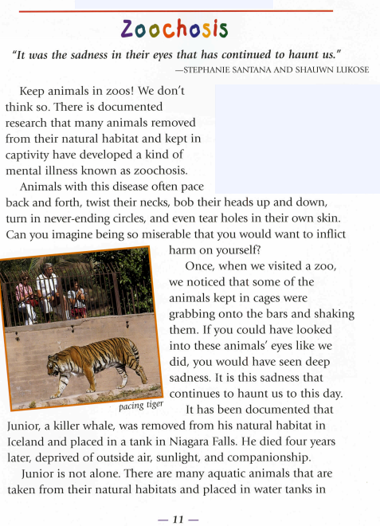

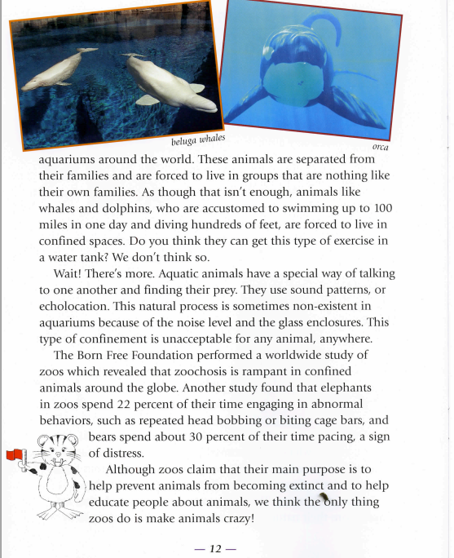

**Task 2: Response to “Zoochosis”**

This article takes a clear position on whether or not zoos are good for animals. Write their position, or what side they’re on, in the box below. Then write details from the text that help us understand that position and that support the authors’ argument. Be sure to quote accurately from the text. You may use some of these details later in your own argument essay.

Do the authors of ―Zoochosis‖ think zoos are good or bad for animals?

__________________________________________________________________

__________________________________________________________________

Text details or evidence that supports this position:

* _______________________________________________________________________________________________________________________________________________________________________________________
* _______________________________________________________________________________________________________________________________________________________________________________________
* _______________________________________________________________________________________________________________________________________________________________________________________
* _______________________________________________________________________________________________________________________________________________________________________________________
* _______________________________________________________________________________________________________________________________________________________________________________________

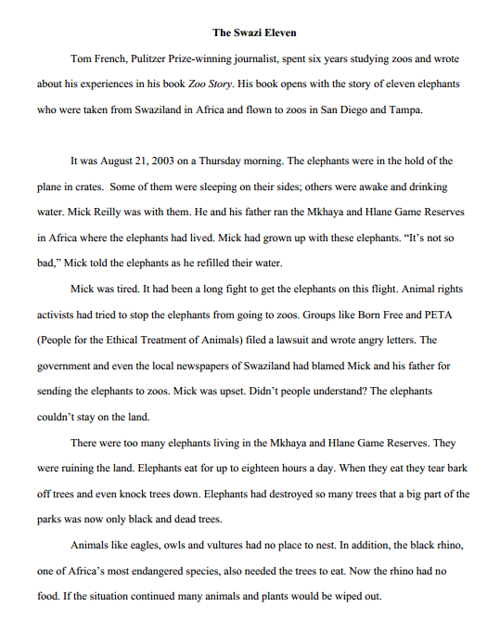

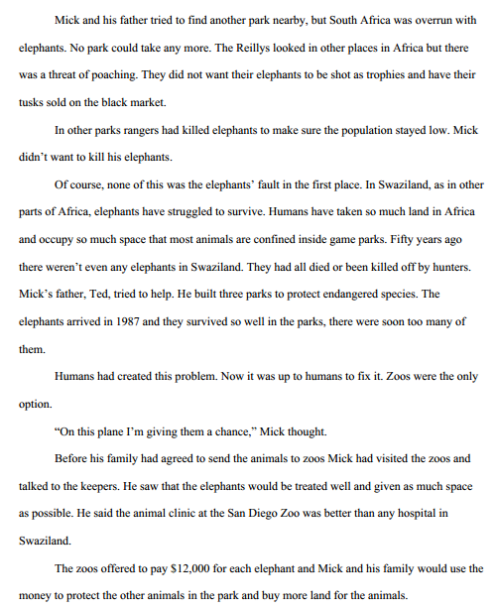

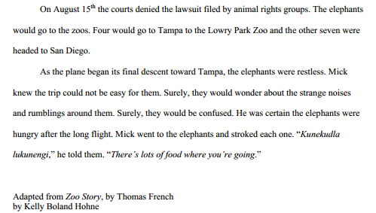

**Task 3: Response to “The Swazi Eleven”**

In this article we learned about elephants in Swaziland. There are problems for the elephants in their natural habitat. According to the article, why is it a problem for elephants to stay in Swaziland? What are some details from the text that help us understand this problem?

According to this article, why is it a problem for elephants to stay in Swaziland? __________________________________________________________________

__________________________________________________________________

Text details or evidence that supports this position:

* _______________________________________________________________________________________________________________________________________________________________________________________
* _______________________________________________________________________________________________________________________________________________________________________________________
* _______________________________________________________________________________________________________________________________________________________________________________________
* _______________________________________________________________________________________________________________________________________________________________________________________
* _______________________________________________________________________________________________________________________________________________________________________________________

Task 4: Summary of “Life Span of Female African Elephants” This note-taking is for your research only. It will not be scored. Look at the graph and write down main ideas and key details that this chart offers on topic of zoos and endangered animals. You may want to use some of this information in your essay.

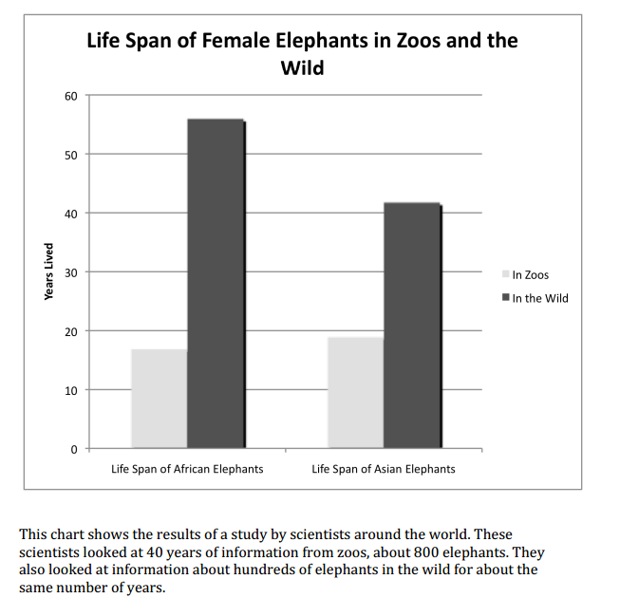_______________________________________________________________________________________________________________________________________________________________________________________________________________________________________________________________________________________________________________________________________________

**Task 5:On your own notebook paper**

Think about everything you’ve learned today. Write an essay, convincing readers that zoos either help or harm animals. Be sure to use evidence to support your opinion. As you write, use information and quotations from the video and any or all the texts you read.

Be sure to:

* Plan
* Introduce the topic
* Make clear whether you believe zoos **help** or **harm** animals
* Include facts and details
* Write a conclusion

Plan:

___________________________________________________________________________________________________________________________________________________________________________________________________________________________________________________________________________________________________________________________________________________________________________________________________________________________________________________________________________________________________________________________________________________________________________________________________________________________Use back of paper if more space is needed for planning.