A poem by Joseph Bruchac

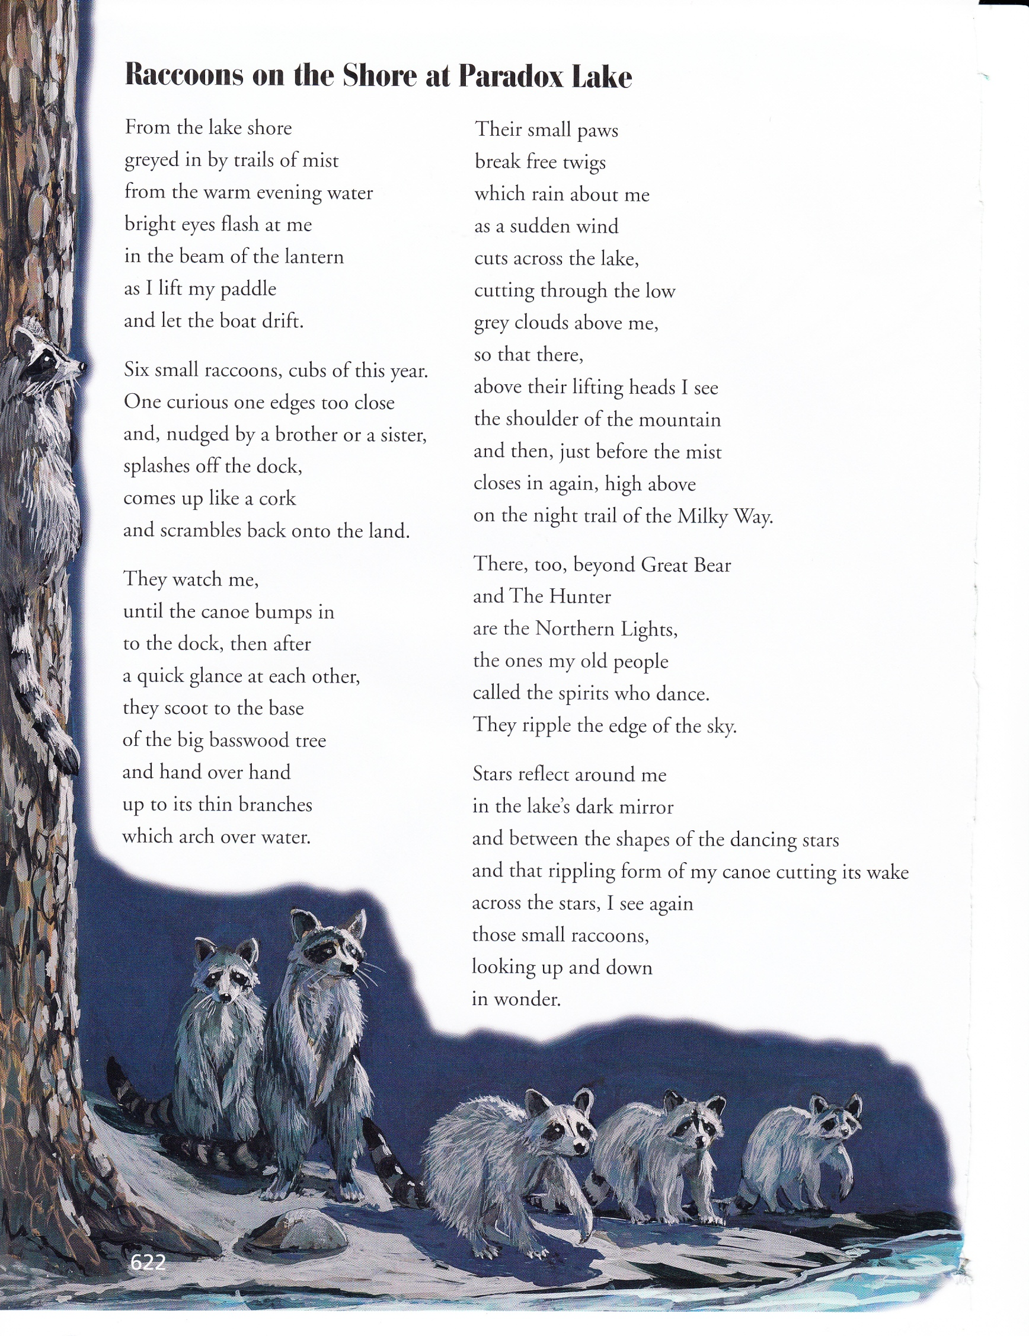

What does the word “reflect” mean as it is used in the passage?

Which phrases best help the reader understand the meaning of “reflect”?

**In .**

In this poem, a person encounters some raccoons. Think about how the author describes the raccoons.

Write an original story describing the same experience from one of the raccoon’s point of view.

________________________________________________________________________________________________________________________________________________________________________________________________________________________________________________________________________________________________________________________________________________________________________________________________________________________________________________________________________________________________________________________________________________________________________________________________________________________________________________________________________________

_____________________________________________________________________________________________________________________________________________________________________________________________________________________________________________________________________________________________________________________________________________________________________________________________________________________________________________________________________________________________________________________________________________________________________________________________________________________________________________________________________________________________________________________________________________________________________________________________________________________________________________________________________________________________