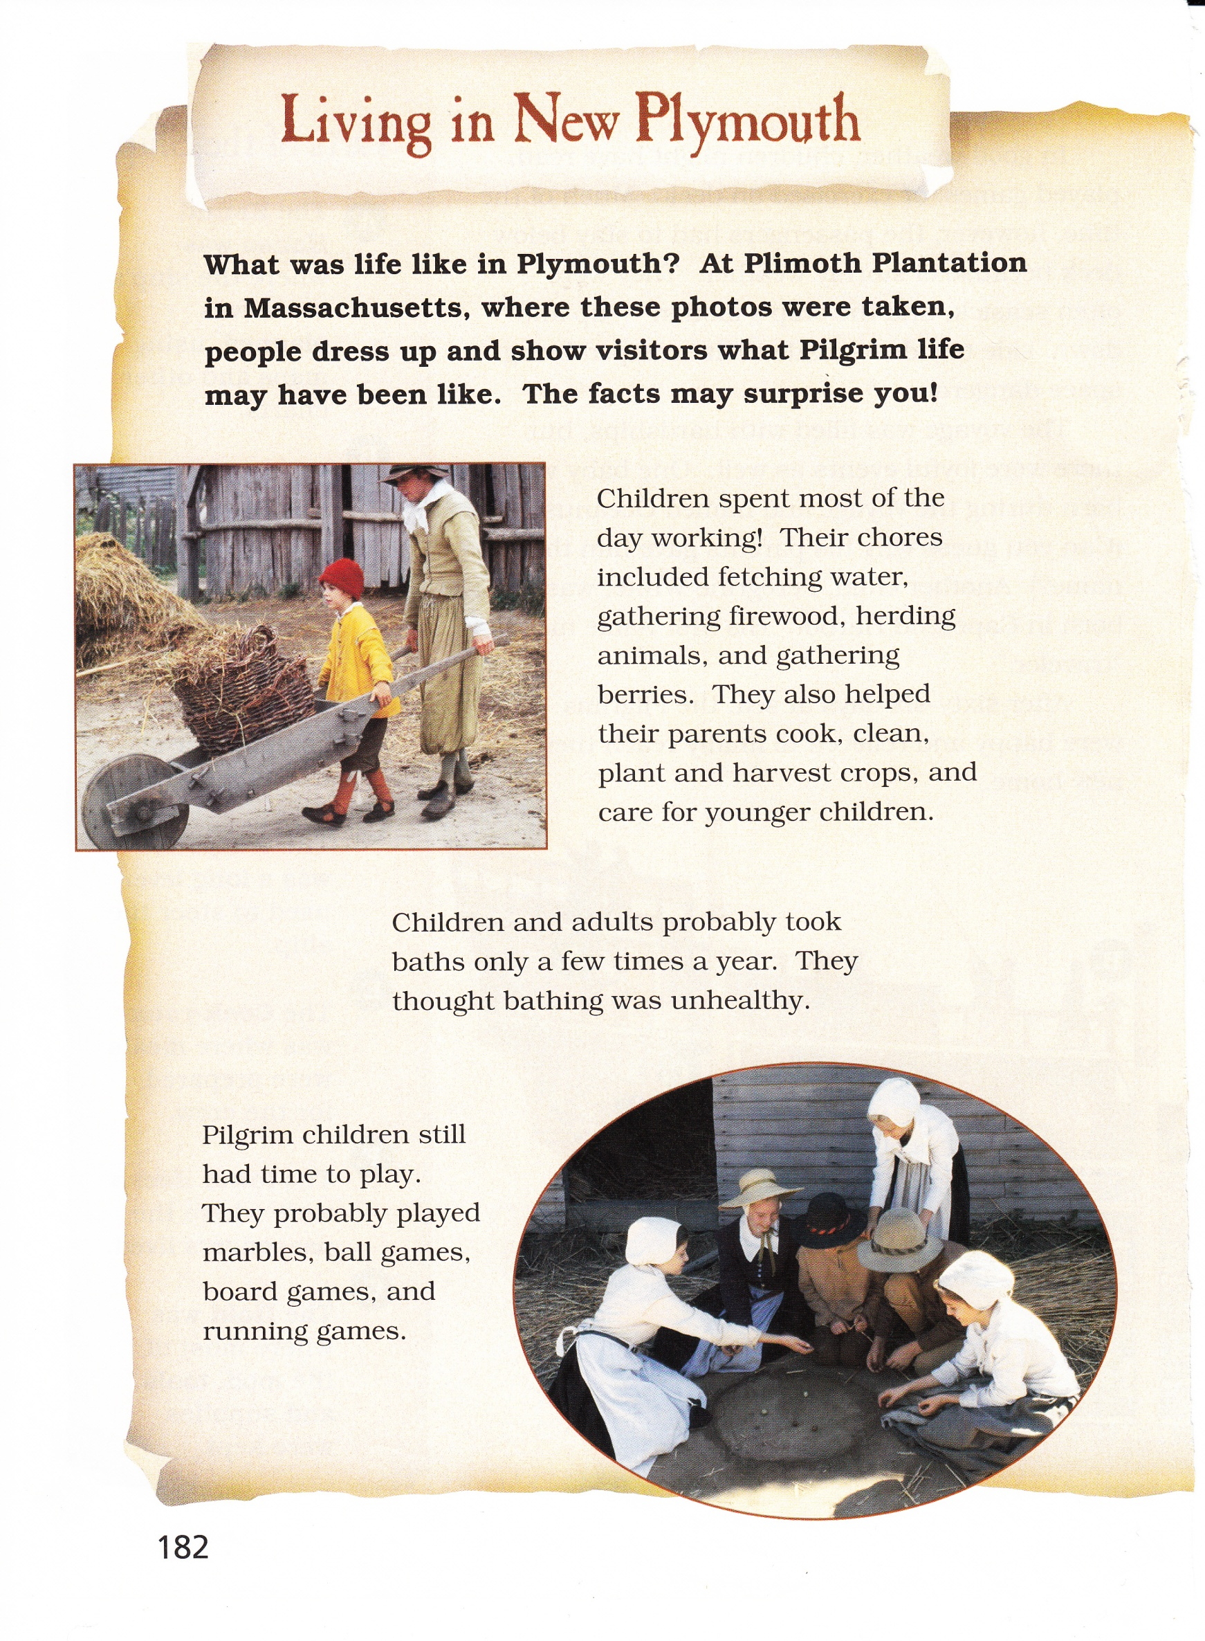

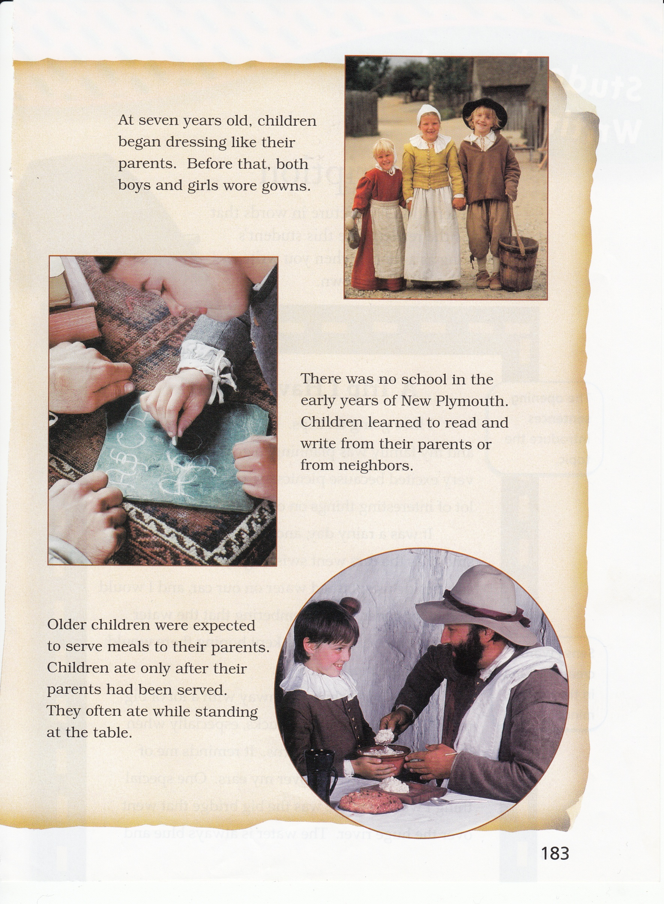

.

In this passage, the author describes daily life at Plimoth Plantation. Think about the details the author used to tell about the lives of children in this time period.

Write a diary entry where you are a child at Plimoth Plantation describing one day of your life. In your entry, be sure to use what you have learned from “Living in New Plymouth” as you tell about your day.

________________________________________________________________________________________________________________________________________________________________________________________________________________________________________________________________________________________________________________________________________________________________________________________________________________________________________________________________________________________________________________________________________________________________________________________________________________________________________________________________________________

_____________________________________________________________________________________________________________________________________________________________________________________________________________________________________________________________________________________________________________________________________________________________________________________________________________________________________________________________________________________________________________________________________________________________________________________________________________________________________________________________________________________________________________________________________________________________________________________________________________________________________________________________________________________________