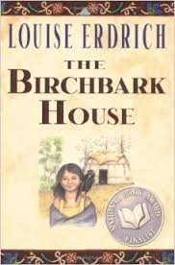Name:__________________________ Date:____________________

After reading Deydey’s Ghost Story (p.64) and Grandma’s Story (p.134) from the Birchbark House, compare the point of view in each story and how it influences the events being described. You are able to use your text and notes from our previous lessons to help you answer the questions.

What are the 3 steps of making a comparison?



Use the table to organize your thoughts:

|  |  |  |
| --- | --- | --- |
|  | Deydey’s Ghost Story | Grandma’s Story |
| Point of View |  |  |
| How are the stories the same? |  |  |
| How does the POV influence the events of both stories? |  |  |

Take your information from your table and WRITE in complete sentences to answer the question about how the point of view in each story influences the events being described.