Additional Texts for Character Studies
Picture Books to Teach Character Traits
Miss Rumphius | Barbara Cooney | 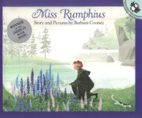
Chrysanthemum | Kevin Henkes | 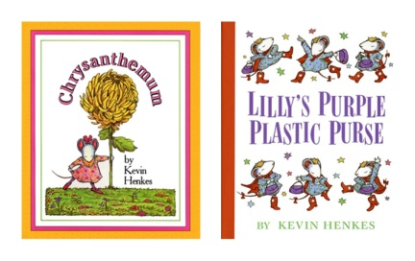
Stellaluna | Janell Cannon | 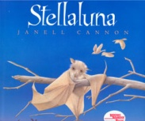
Thank You, Mr. Falker | Patricia Polacco | 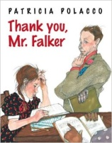
The Paper Bag Princess | Robert Munsch | 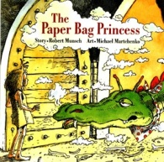
Old Henry | Joan W. Blos | 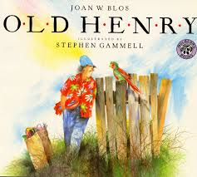

Picture Books to Teach Character Change
Boundless Grace | Mary Hoffman | 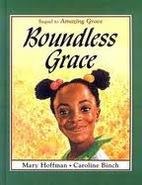
A Weekend With Wendell | Kevin Henkes | 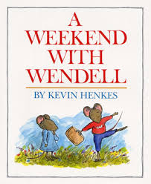
Julius, Baby of the World | Kevin Henkes | 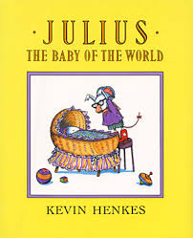
Edward the Emu | Sheena Knowles | 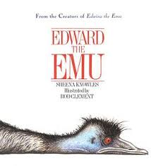
Ish | Peter Reynolds | 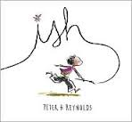
Table Where Rich People Sit | Byrd Baylor | 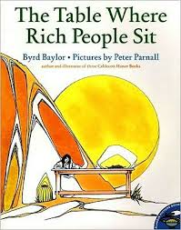
The Old Woman Who Named Things | Cynthia Rylant | 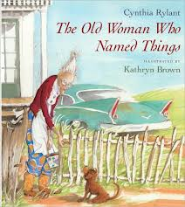

Picture Books to Teach Character Conflicts
Character vs. Character
The Ugly Duckling | Hans Christian Anderson | 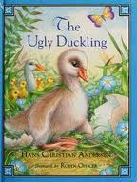
Dogzilla | Dav Pilkey | 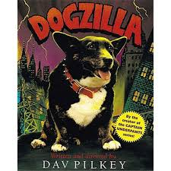
Suddenly! | Colleen McNaugton | 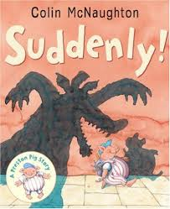
Character vs. Self
Edward the Emu | Sheena Knowles
Ira Sleeps Over | Bernard Waber | 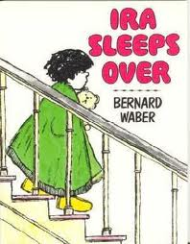
Thunder Cake | Patricia Polacco | 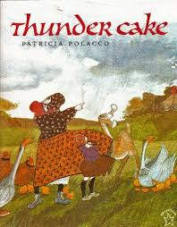
Character vs. Nature
Ghost Eye Tree | Bill Martin, Jr. | 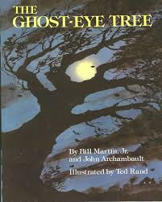
The Last Dinosaur | Jim Murphy | 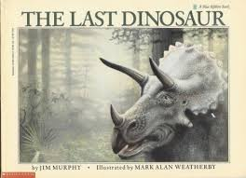
The Lorax | Dr. Suess | 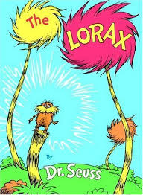

Character vs. Society
Teammates | Peter Golenbock | 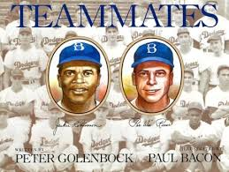
Wings | Christopher Meyers | 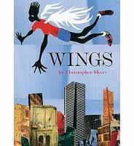
Yo? Yes! | Chris Raschka | 