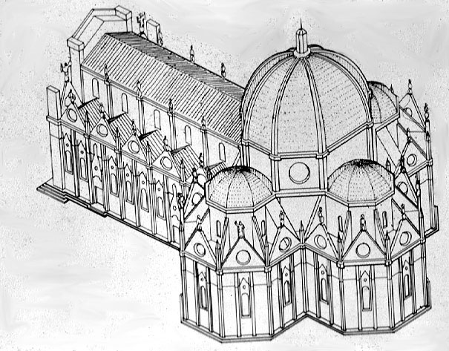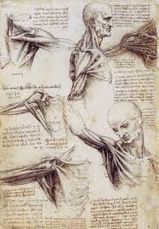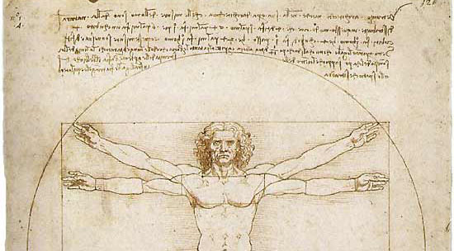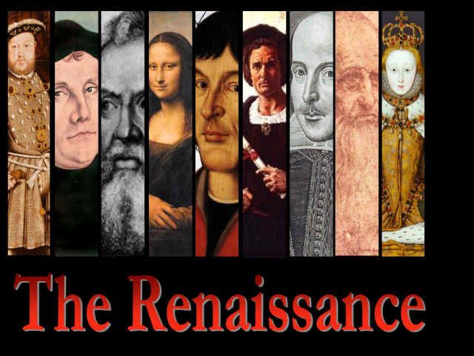______________________________________________________________________________________________________________________________________________________________________________________________________________________________________________________________________________________________________________________________________________________________________________________________________________________________________________________________________________________________________________________________________________________________________________________________________________________________________________________________________________________________________________________________________________________________________________________________________________________________________________________________________________________________________________________________________________________________________________________________________________________________

What:

Where:

When:

**Leonardo Da vinci**

Fact tracker

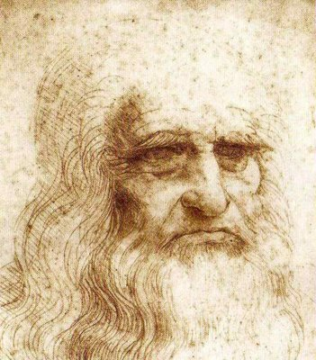

________________________________________________________________________________________

_______________________________________________________________________________________________

_______________________________________________________________________________________________

_______________________________________________________________________________________________

__________________________________________________________________________________________

__________________________________________________________________________________________________________________

__________________________________________________________________________________________

_________________________________________________________________________________________________________________________________________________

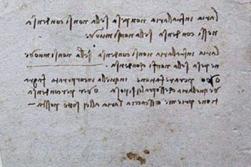

What was interesting about Leonardo’s journals? Explain why he used this style of writing. __________________________________________________________________________________________________________________________________________________________________________________________

Re-write this sentence using mirror writing:

“*Leonardo was born in 1452.”*

________________________________________________________________________________________________________________

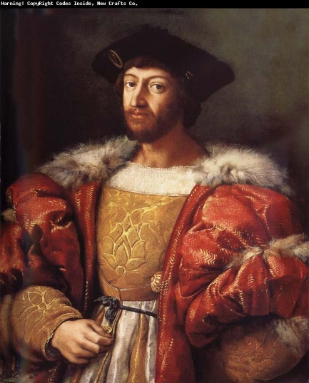__________________________________________________________________________________________________________________________________________________________________________________________________________________________________________________________________________________________________________________________________________________________________________________________________________________________________________________________________________________________________________________________________________________________________________________________________________________________________________________________________________________________________________________________________________________________________________________________________________________________________________________________________________________________________________________________________________________________________________________________________________________________________________________________________________________________________________________________________________________________________________________________________________________________________________________________________________________________________________________________________________________________________________________________________________________________________________________________________________________________________________________

***“Leonardo had been drawing since he was a child. His father knew that his son was very gifted. He took some of Leonardo’s drawings to a famous artist named Verrocchio. Verrocchio agreed to take Leonardo as his apprentice.***

***Apprentices often began working when they were fourteen. Experts think that Leonardo was about sixteen when he joined Verrocchio.”***

An apprentice is… __________________________________________________________________________

**If you had to become an apprentice, what type of career would you choose? Why did you select this career? Is there a person that you’d like to learn from?**

Everyone has a different idea of what art is? How do you decide whether or not something is art? Explain.

________________________________________________________________________________________________________________________________________________________________________________________________________________________________________________________________________________________________________________________________________________________________________________________________________________________________________________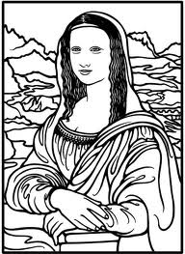

______________________________________________________________________

______________________________________________________________________

______________________________________________________________________

______________________________________________________________________

______________________________________________________________________

______________________________________________________________________

***Mona Lisa***

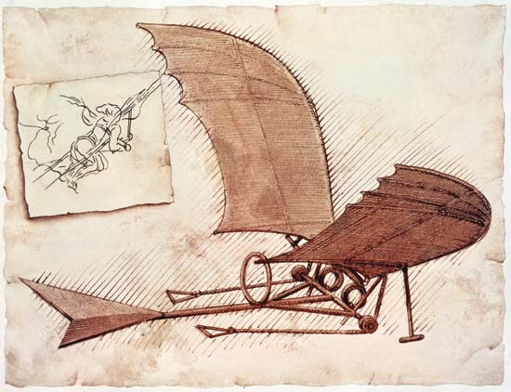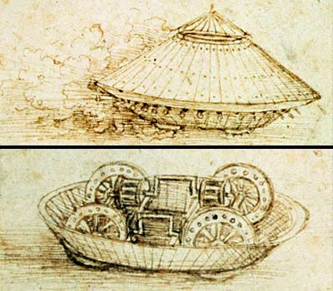

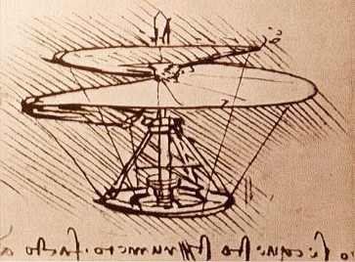

Leonardo created these designs for the first military tank, helicopter, and glider 400 years before they were actually invented. Draw your futuristic invention below. You might create something entirely new or take a current product and make it better.

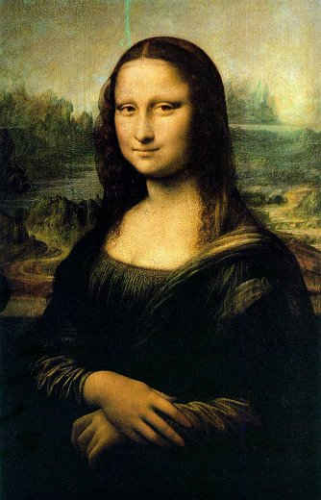

MISSING

Help! The world’s most famous painting, The Mona Lisa, has been stolen? Create a story about the search for the missing painting. Your story must have these characters:

Detective Holmes…the wicked smart & heroic police detective

Wendall Scorn…the equally intelligent art thief

Arnold Space…the easily tricked and often sleepy night watchman

______________________________________________________________________________________________________________________________________________________________________________________________________________________________________________________________________________________________________________________________________________________________________________________________________________________________________________________________________________________________________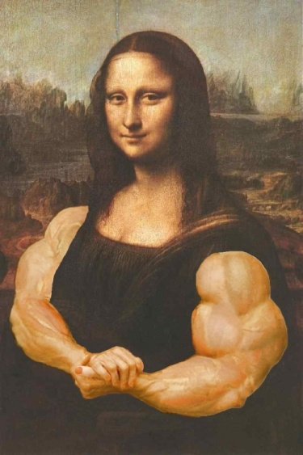________________________________________________________________________________________________________________________________________________________________________________________________________________________________________________________________________________________________________________________________________________________________________________________________________________________________________________________________________________________________________________________________________________________________________________________________________________________________________________________________________________________________________________________________________________________________________________________________________________________________________________________________________________________________________________________________________________________________________________________________________________________________________________________________________________________________________________________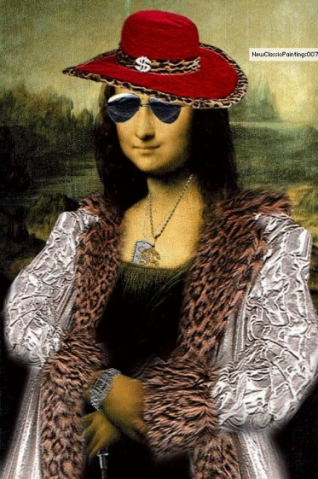__________________________________________________________________________________________________________________________________________________________________________________________________________________________________________________________________________________________________________________________________________________________________________________________

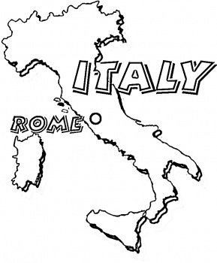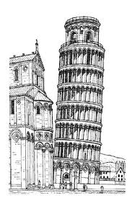

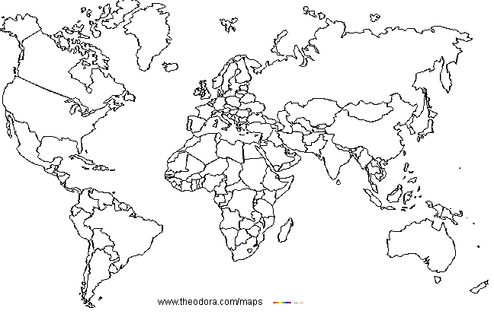

Color the United States red, Europe orange,

Africa purple, Asia yellow, Australia green,

& South America dark blue.

Label the Pacific, Atlantic & Indian Oceans

Shade ocean areas blue

Draw a green circle around Italy

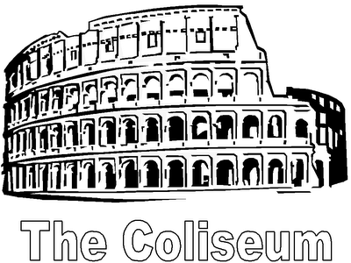

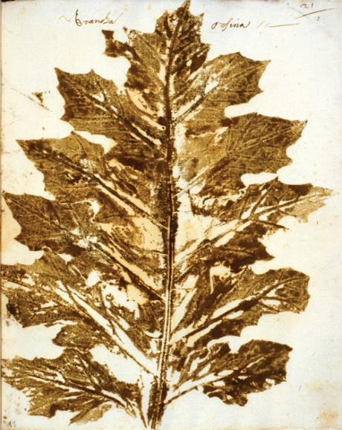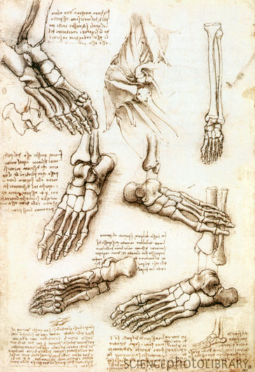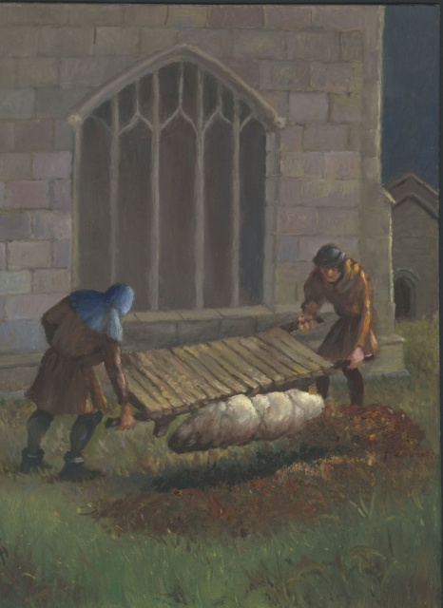

ATeague and SBerens 2012

Botanist

__________________________________________________________________

Dissect ___________________________________________________________________________

Plague ________________________________________________________________________________________________________________________________________________________________________

Guilds

________________________________________________________________________________________

Cathedral

______________________________________________________________________________________________________

Patron: ____________________________________________________________________________