*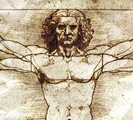5th Grade, Unit 2 Formative Assessment*

This assessment is meant to measure progress towards the following standards:

* RI.5.2 **Determine two or more main ideas of a text and explain how they are supported by key details**; ~~summarize the text.~~
* RI.5.4 Determine the meaning of general academic and domain-specific words and phrases in a text relevant to a grade 5 topic or subject area.

Students are expected to define the terms “main idea” and “key details.” Students will then identify one main idea for the passage and key details supporting the main idea. In future units and assessments, students will be asked to determine “two or more main ideas” in order to meet end of year expectations.

Because we know that vocabulary is typically a tricky spot for our students, questions 1-3 address standard RI.5.4. Questions 4 and 5 measure standard RI.5.2.

Directions for Giving the Assessment:

Students should spend 10 minutes independently reading the passage and answering the questions on this assessment. Encourage students, especially struggling readers, to think about strategies they have for reading difficult passages/texts.

After 10 minutes, please read the passage and questions aloud for the class. If asked, continue to read aloud any portion of the passage or question. While we know that *read aloud* is not an allowable accommodation on the reading portion of high-stakes testing, the purpose of this assessment is to measure reading comprehension…not independent reading comprehension.

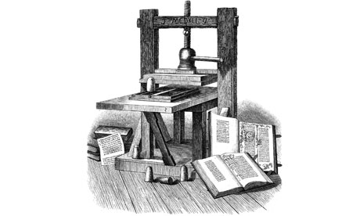In about 1450, a man named Johannes Gutenberg who worked as a goldsmith in Germany combined some existing inventions into a brand-new one that would change the course of history.

Gutenberg and the Printing Press

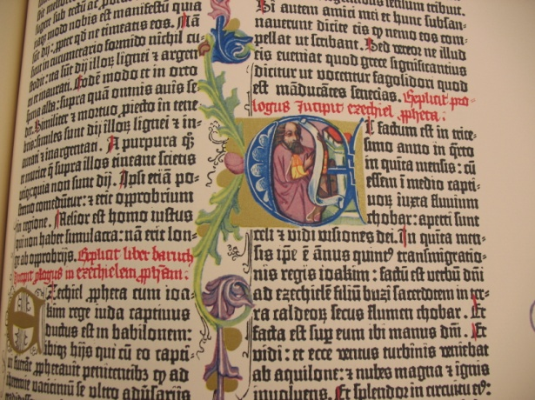Using his knowledge of metals, Gutenberg perfected “movable type” (something that had already been invented in China). Movable type are little molds of letters and punctuation. They can be arranged in any combination on a rack and then inked for printing. In about 1450, Gutenberg combined movable type with a simple mechanical press—the same kind that was used to squeeze oil out of olives or juice out of grapes—to make a mechanical printing press. Working together, two or three printers could produce over 3,600 pages a day—a lot more than the few pages that a ***scribe*** could make copying by hand.

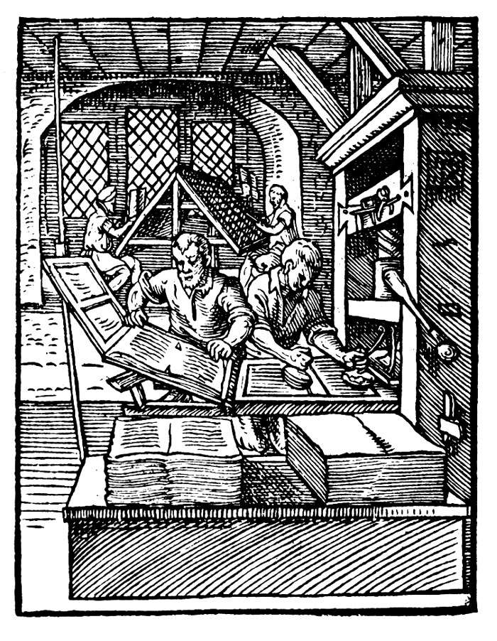The first book produced with the new printing press was the Gutenberg Bible—and it was a sensation. People all over wanted copies. Within a few years, there were hundreds of print shops around Europe—and Italy was the printing capital of the world. Suddenly a book like The Decameron was available in thousands of copies. With the explosion of books came an explosion in literacy and education. More and more people were learning how to read, and more books were being written. The “light” that the early humanists dreamed of was glowing brighter and brighter.

The Renaissance version of a selfie, this is a print of an early print shop. This illustration from 1568 shows two printers working together on a Gutenberg-style press—the printer on the right is inking the type for the next pressing and the printer on the left is removing a freshly printed sheet. In the background, compositors are setting new pages of type on forms.

1. What does the term “main idea” mean?

Name: _________________________

1. How are **key details** different from **details**?
2. If you were a ***scribe*** during the renaissance, what was your job? How did the invention of the printing press change your life? Use evidence from the passage to support your response.
3. The main idea of ***this*** passage is:
4. Which of the following are ***key details*** from the passage? (choose all that apply)
   * Two or three printers could produce over 3,600 pages a day.
   * Within a few years, there were hundreds of print shops around Europe.
   * With the explosion of books came an explosion in literacy and education
   * The Decameron was available in thousands of copies
   * Gutenberg perfected “movable type”.
   * Johannes Gutenberg worked as a goldsmith in Germany.
   * The first book produced with the new printing press was the Gutenberg Bible.
5. What does the term “main idea” mean?

Name: _________________________

What the author wants you to remember most

1. How are **details** different from **key details**?

Details are any and all facts or pieces of evidence found in the text. Key details are the facts and evidence that support the main idea.

1. If you were a ***scribe*** during the renaissance, what was your job? How did the invention of the printing press change your life? Use evidence from the passage to support your response.

A scribe was responsible for making copies of books or texts. They wrote these texts by hand. The printing press could make copies of books much faster than a scribe. According to the text, the printing press could produce “a lot more than the few pages that a scribe could make copying by hand.” The reader can infer that the printing press may have caused scribes to lose their job because the machine could work faster than the scribe.

1. What is the main idea of ***this*** passage?

Johannes Gutenberg’s printing press changed the way books were made and who had access to them.

1. Which of the following are ***key details*** from the passage? (choose all that apply)
   * Two or three printers could produce over 3,600 pages a day.
   * Within a few years, there were hundreds of print shops around Europe.
   * With the explosion of books came an explosion in literacy and education
   * The Decameron was available in thousands of copies
   * Gutenberg perfected “movable type”.
   * Johannes Gutenberg worked as a goldsmith in Germany.
   * The first book produced with the new printing press was the Gutenberg Bible.