Prior to this lesson: Prior to this the teacher needs to read the 1st Inning of We are the Ship by Kadir Nelson
Unit 1 | Playing with Words  Unit Essential Question: Why and how do we play with language?
Materials | We are the Ship by Kadir Nelson  Copy of page 9 for each student
STANDARDS | L.4.4.a. Use context as a clue to the meaning of a word or phrase.
Lesson Structure | High Yield Strategies | Lesson Plan (90 minutes- Reading + Word Work)
Goal  (2 minutes) | (8) Setting Objective and Providing Feedback  (4) Reinforcing effort and Providing Recognition | I can use context clues to help me figure out the meaning of unknown words or phrases.  Record the goals in notebooks and self-score understanding before the lesson.
Access Prior Knowledge  (3minutes) | (6) Nonlinguistic Representations  (7) Cooperative Learning  (10) Cues, Questions and Advance Organizers | 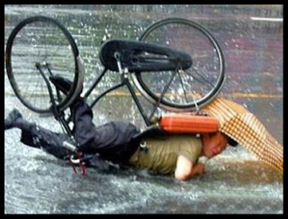  What is going on in this picture?
New Information  (20 minutes) | (3) Summarizing and Note Taking  (5) Homework and Practice  (11) Teaching Specific Types of Knowledge | Context clues are hints that the author gives to help define a word you don’t know. The clue may appear in the same sentence as the word you don’t know or in a nearby sentence.  This is a useful and important strategy because it helps you understand what you are reading, and it allows you to easily learn new vocabulary.  Model using context clues for the word prohibited on page 2 of We are the Ship.

Application  (60 minutes) | Declarative  (2) Indentifying Similarities and Differences  (3)Generating and Testing Hypotheses  (10) Cues, Questions and Advance Organizers | Procedural  (5) Homework and Practice | Give each student a copy of page 9 from We are the Ship. Pair students together and have them use context clues to discover the meaning of the words integrate and dignity.
Goal  (2 minutes) | (8) Setting Objective and Providing Feedback  (4) Reinforcing effort and Providing Recognition |  | Revisit the goals and record understanding after the goal.  Self-score the amount of effort put into the lesson.

