5th Grade – Unit 1: Playing with Words
Suggested Scope and Sequence
Week | Focus Standard | Vocabulary Addressed | District Resources | Suggested Activities
Week 1  Goal: I can identify the structure of prose.  Guiding Questions:  How does the author build his/her story (in each chapter) to help me understand?  What happens in the beginning chapters? How do they set up what happens in the next chapters and how do these chapters develop the story for the chapters at the end?  *Modify for storybook/chapter use | RL.5.5 –Story Structure:  Explain how a series of chapters fit together to provide the overall structure of a particular story.  Correlating Standards:  RL.5.1 Key Ideas and Details: Quote accurately from a text when explaining what the text says explicitly and when drawing inferences from the text – Used during close reading to identify story parts by quoting from the text  SL.5.2 Summarize a written text read aloud both orally and visually –Used when students draw/label story structure and explain it verbally | Prose Structure:  - Prose  - Exposition  - Rising action  - Climax  - Falling action  - Resolution  - Setting  - Characters  - Plot  - Conflict  - Dialogue  - Paragraph  - Chapter  - Beginning, Middle, End  *Optional:  Authors use these techniques to create tension in the story/chapters:  - Flashbacks  - Cliffhangers  - Foreshadowing  - Suspense  *Definitions provided in Teacher Created Resources | Tops and Bottoms (from 3rd grade, Unit 1)  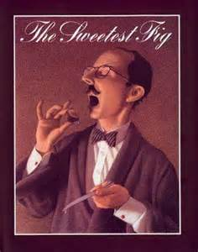  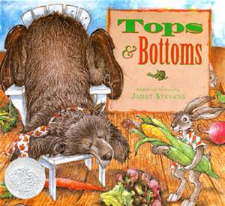  The Sweetest Fig  (from 2nd grade, Unit 6)  Henry’s Freedom Box  (from 2nd grade, Unit 4)  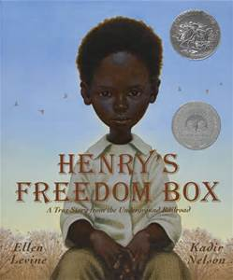  Martina the Beautiful  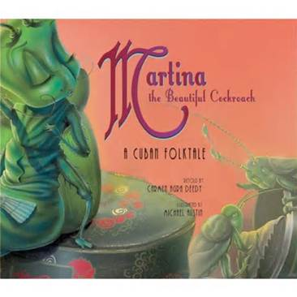  Cockroach (from 2nd grade, Unit 5)  *Any teacher selected picture book with strong story structure  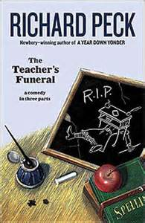  The Teacher’s Funeral  (from 5th grade, Unit 1) | - Introduce story structure using The True Story of the 3 Little Pigs PowerPoint (*in Teacher Created Resources). Label story structure elements, define them, use a foldable)  - Scaffold story structure with at least 2 suggested storybook texts in whole group guided practice  - Have students practice identifying story structure in small groups after listening to a storybook read aloud - use a graphic organizer  - Chart story structure in AR books  - Read Aloud: Teacher’s Funeral- chart story structure  - Formative Assessment: Independently chart story structure from a leveled book/read aloud

Week | Focus Standard | Vocabulary Addressed | District Resources | Suggested Activities
Week 2  Goal: I can identify the structure of poetry as compared to prose.  Goal: I can identify the structure of a drama as compared to prose and poetry.  Guiding Questions:  Poetry:  What is the main idea of the first stanza? How do the following stanzas help to develop the text? Why do I think they’re written in that particular sequence?  Drama:  How do the scenes build on one another? What happens in the first scenes to set up the drama? How are the following scenes sequenced? | RL.5.5 –Poetry and Drama Structure:  Explain how a series of stanzas or scenes fit together to provide the overall structure of a particular poem or drama.  Correlating Standards:  RL.5.1 Key Ideas and Details: Quote accurately from a text when explaining what the text says explicitly and when drawing inferences from the text – Used during close reading to identify poem and drama parts by quoting from the text  SL.5.2 Summarize a written text read aloud both orally and visually –  Used when students draw/label poem/drama structure and explain it verbally  RF.5.4b Read on-level prose and poetry orally with accuracy, appropriate rate orally on successive readings  -Use poems/reader’s theater for fluency practice | Poetry Structure:  - Stanza  - Verse  - Rhyme  - Rhythm  - Meter  - Repetition  Drama Structure:  - Drama  - Cast of characters  - Narrators  - Stage directions  - Scenes  - Acts  - Settings  - Script  - Dialogue  *Definitions provided in Teacher Created Resources | Poetry:  *Any teacher-selected poetry will work; however, here are a few suggestions.  Suggestions (Provided in Teacher Created Resources):  - “Still I Rise” (excerpt)  by Maya Angelou  - “Road Not Taken”  by Robert Frost  - “If”  by Rudyard Kipling  - “I Choose the Mountain”  by Howard Simon  *Remember to keep it varied and short.  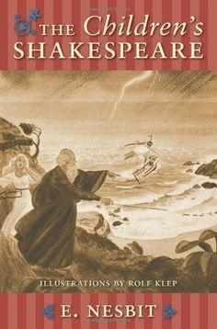  Drama: Shakespeare for Kids (from 5th grade, Unit 1)  *Reader’s Theater Scripts  Read Aloud:  The Teacher’s Funeral  (from 5th grade, Unit 1) | Poetry:  - Mirror activities from Week 1 to introduce and discover poetry structure (introduce vocabulary, use a foldable, model, group practice, etc.)  - Use highlighters as a whole class and in groups to find and identify poetry structure elements  - Discuss how stanzas build upon each other  Drama:  - Mirror prose/poetry activities  - Watch an excerpt of a drama  - Perform Reader’s Theater for an example of a drama  Assess students on knowledge of both structures  Prose/Drama/Poetry:  - Create a 3 column chart to discuss differences  Continue to:  - Chart story structure in AR books  - Read Aloud: Teacher’s Funeral- chart story structure

Week | Focus Standard | Vocabulary Addressed | District Resources | Suggested Activities
Week 3  *This may take two weeks.  Goal: I can determine the meaning of words and phrases including figurative language.  Guiding Questions:  How do authors play with language?  Why do authors play with language? | RL.5.4- Determine the meaning of words and phrases as they are used in a text, including figurative language such as metaphors and similes.  Correlating Standards:  L.5.5 Demonstrate the understanding of figurative language, word relationships and nuances in word meanings  a. Interpret figurative language, including similes and metaphors, in context.  b. Recognize and explain the meaning of common idioms, adages, and proverbs.  c. Use the relationship between particular words (e.g., synonyms, antonyms, homographs) to better understand each of the words.  RF.5.4b Read on-level prose and poetry orally with accuracy, appropriate rate orally on successive readings  -Use poems/reader’s theater for fluency practice | Figurative Language Devices:  - Simile (focus)  - Metaphor (focus)  - Onomatopoeia  - Alliteration  - Idiom  - Personification  - Hyperbole  - Proverbs  - Paradox  - Irony  - Euphemism  - Puns  - Adages  - Synonym  - Antonym  - homograph  *Definitions provided in Teacher Created Resources | *Revisit previous suggested texts to identify figurative language devices  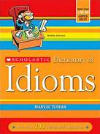  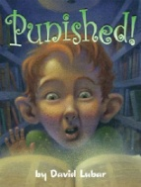  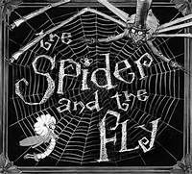  The Spider and the Fly (from 5th grade, Unit 5)  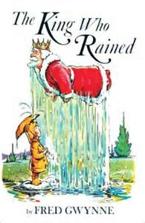  The King Who Rained (from 5th grade, Unit 1)  Scholastic Dictionary of Idioms (from 5th grade, Unit 1)  Runny Babbit (from 5th grade, Unit 1)  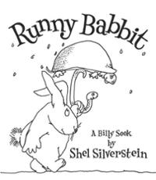  Punished! (from 5th grade, Unit 1) | - Explicit Figurative Language instruction  - Create Interactive Anchor Charts (ongoing) for students to post figurative language found in self-selected novels  - Create an anchor chart identifying reasons author’s play with language (Essential Question)  - Revisit previously read storybooks, poems, and dramas and use new texts to identify figurative language devices  - Revisit The Teacher’s Funeral to identify figurative language  - Read Aloud: Punished!- chart story structure and figurative language  Continue to:  - Chart story structure in AR books AND have students identify figurative language in independent reading.

Week | Focus Standard | Vocabulary Addressed | District Resources | Suggested Activities
Week 4  Goal: I can explain how author’s word choice affects the mood and tone of prose, poetry, and dramas.  Guiding Questions:  How do authors play with language?  Why do authors play with language?  What is the tone or mood in this text?  How does the language in this section set a tone? How does the tone help me understand what the characters are thinking right now? | RL.5.4- Determine the meaning of words and phrases as they are used in a text, including figurative language such as metaphors and similes.  Correlating Standards:  L.5.5 Demonstrate the understanding of figurative language, word relationships and nuances in word meanings  a. Interpret figurative language, including similes and metaphors, in context.  b. Recognize and explain the meaning of common idioms, adages, and proverbs.  c. Use the relationship between particular words (e.g., synonyms, antonyms, homographs) to better understand each of the words.  RF.5.4b Read on-level prose and poetry orally with accuracy, appropriate rate orally on successive readings  -Use Joyful Noise: Poems for Two Voices | - Tone  - Mood  *Definitions provided in Teacher Created Resources | *Revisit previous suggested texts to identify tone and mood.  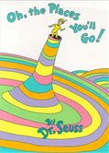  Punished! (from 5th grade, Unit 1)  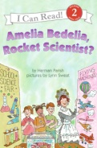  Amelia Bediala books (from 3rd grade, Unit 5)  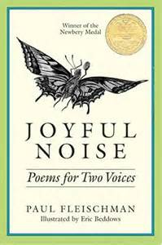  A Long Way from Chicago (from 5th grade, Unit 6)  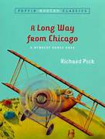  Oh, the Places You’ll Go! (from 5th grade, Unit 1)  Joyful Noise: Poems for Two Voices (from 5th  grade, Unit1) | - Explicit instruction on tone and mood (create an anchor chart).  - Model identifying the author’s tone and its effect on mood with previously read storybooks, poems, dramas, etc. Then, allow students to do this in small groups, etc. *Use The Teacher’s Funeral to identify tone and mood in specific chapters.  - Have students work in centers (focus on a comparative look at multiple authors’ use of language: i.e. Seuss, Richard Peck, Shakespeare, Barbara Park (Junie B.), Amelia Bedelia, etc…)  Continue:  - Read Aloud: Punished!- chart story structure, chart figurative language, and determine the mood/tone of chapters.  - Figurative Language Interactive Anchor Chart  - Continue independent practice in AR books.

