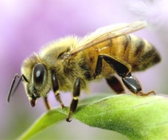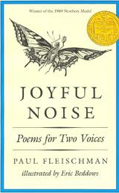*Honeybees*

Poem by Paul Fleischman

Name:_________________________________ Teacher:_____________________

RL.5.2 Determine a *theme* of a story, drama, or poem from details in the text, including how characters in a story or drama respond to challenges or how the speaker in a poem *reflects* upon a topic; *summarize* the text.

|  |  |
| --- | --- |
| What is the theme of the poem? | |
| How does the character (reader) reflect on his/her life as a bee? Use evidence from the text to support your answer. | |
| Reader #1 | Reader #2 |
| What is the summary of this poem? | |
| How would the poem change if you took out one of the characters from the poem? | |