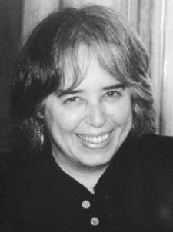Jane Yolen

Adapted from www.janeyolen.com/biography

I was born on February 11, 1939 in New York City at Beth Israel Hospital, the first child of my parents, Isabel Berlin Yolen and Will Hyatt Yolen. Because my grandmother Mina Hyatt Yolen’s family, the Hyatts, only had girls, a number of us were given their last name as a middle name to carry it on. So I am Jane Hyatt Yolen, and my brother, Steven Hyatt Yolen, was born three and a half years later. Alas, we are no relation to the Hyatt Hotels, no matter how often I have tried to convince the staffs there.

My father was a café journalist at the time, writing columns for the New York newspapers. He’d been a police reporter before that. My mother was a psychiatric social worker until I was born. After that, she never held another full-time out of the home paid job (though she did volunteer work), but wrote short stories that didn’t sell and crossword puzzles and acrostics that did.

When my father got a higher paying job, being a publicity flack for Hollywood movies, we moved to California. I was barely one. We stayed there for a couple of years while he worked on such movies as “American Tragedy” and “Knut Rockne” (“Let’s win one for the Gipper” Starring Ronald Reagan.)

4

After living in California for a short time, we came back to New York City in time for the birth of my brother Steve. Soon after, Daddy went into the army as a Second Lieutenant and was shipped off to England for World *War II. Mommy, Stevie, and I spent the war years in Newport News with her mom and dad, Grandma Fanny* and Grandpa Dan. Meanwhile Daddy served as head of ABSIE, the secret radio in London, but was wounded in the buzz bombs. He came home a hero. He told me that he’d won the war single-handedly, and I believed him.

In New York, I went to PS 93, where I was a gold star kid, writing up a fury and singing with my pals Sue Hodes (who is now a well known painter) and Sue Levitt (who is now Susan Stamberg of NPR radio) and others. I took piano lessons and studied ballet at Balanchine’s School of American Ballet. Then I tested and got into Hunter Junior High School and discovered that there were a lot of gold star girls all over the city. What a shock! I had to work hard just to stay in the middle of the class.

During this time, my brother and I created a newspaper for our apartment. We wrote all the articles and interviewed our neighbors. My mother typed up the copies (this was long before either computers or copy machines made the process easier) and we sold the ***things*** for five cents each to the same neighbors we’d interviewed. Five cents bought a lot of candy and comic books back in the day.

6

Two years later, I tested and got into Music and Art High School and was looking forward to starting in the fall. My parents had other plans for us. That summer, without telling us, they bought a house in Westport, Connecticut. Our Aunt Isabelle and Uncle Harry came for us and brought us to the new house. What a surprise! It was a large ranch house set on a couple of acres. A girl just a grade below me, Carol Tropp, lived next door with her parents and younger sister. And off I went to Bedford Junior high for ninth grade, and then Staples High School. I sang in the choir, was captain of the girls’ basketball team, won the debate awards, was News Editor of the school paper, vice president of the Spanish and Latin Clubs … a gold star kid.

I graduated seventh in my class. If I had worked hard, I might have been third. Then I might have gotten into my first choice college— Radcliffe. As it was I was accepted at Oberlin, Wellesley, and Smith. I chose Smith.

At Smith College, I discovered (again) that all the gold star girls around America were there. I had to work hard just to stay in the middle of the class. But by the end of my four years, I was president of the Press Board, won all the poetry writing awards, the journalism award—and wrote the lyrics to the class musical as well as starred in our senior show. I didn’t have the highest grades, but I wrote a book of poetry, many poems of which were published in various small journals like *The Grecourt Review*, and *i.e* and the *Chicago Jewish Forum*.

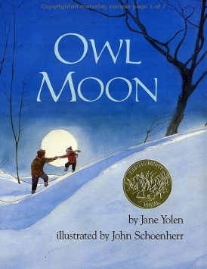After college, I moved to New York City and became an editor—writing during lunch breaks and evenings and weekends. I considered myself a poet and a journalist/nonfiction writer. But to my surprise, I became a children’s book writer, selling my first book on a cold February day. My 22nd birthday, as a matter of fact. It was called *Pirates in Petticoats.*

I love being a writer. I have written over 300 books at last count.

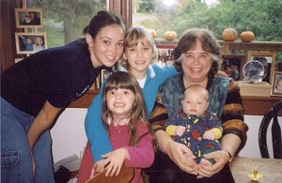I married David W. Stemple in 1962. He and I have three children and six grandchildren. Alas, he died of cancer in March, 2006 after 44 years of a wonderful marriage. I live in Western Massachusetts right next door to my marvelous daughter Heidi (the little girl in OWL MOON) and her two daughters. My sons live far away with their familes, Adam in Minneapolis, Jason in Charleston, SC.  I also have a house in Scotland where I live about four months of the year. The rest of my life is all book talk. You can find it elsewhere on this website.

1 Where did Jane Yolen hope to go to college?

A Oberlin

B Smith

C Wellesley

D Radcliffe

2 What does “single-handedly” mean as it is used in paragraph 4?

A missing one hand

B fighting in war

C by yourself

D winning a war

3 What “***things”*** is Jane Yolen talking about when she says “…we sold the ***things*** for five cents…”?

A newspapers

B ballets

C brothers

D apartments

4 Some of Jane’s early poems were published in-

A Owl Moon

B Press Board

C *The Grecourt Review*

D *Pirates and Petticoats*

5 How did Jane’s mother make money for her family?

A radio reporting

B writing acrostic poems

C writing stories

D volunteer work

6 Which school did Jane Yolen *NOT* attend?

A PS93

B Staples High School

C Bedford Junior High

D Music and Art High School

7 According to the passage, Jane Yolen has lived in New York, Connecticut, and –

A Charleston

B Minneapolis

C California

D Arkansas

8 Jane Yolen and her ___________ made their own newspaper.

A brother

B father

C husband

D daughter

**Jane Yolen**

|  |
| --- |
| **READING OPEN-RESPONSE ITEM A** |

1. In this passage, Jane Yolen says that she was a “gold star kid.” Explain what it means to be a “gold star kid.” Give two examples from the passage to support Jane Yolen being a gold star kid.

|  |
| --- |
| **A**  **____________________________________________________________________________________________________________________________________________________________________________________________________________________________________________________________________________________________________________________________________________________________________________________________________________________________________**  **____________________________________________________________________________________________________________________________________________________________________________________________________________________________________________________________________________________________________________________________________________________________________________________________________________________________________**  **___________________________________________________________________________________________________________________________________________________________________________________________________________________________________________________________________________________________________________________________________________________________________________________________________________________________________**  **____________________________________________________________________________________________________________________________________________________________________________________________________________________________________________________________** |