Stories from the Earth and Sky

Name:

Legend of

Answer this with your partner:

What was the moral of this story?

Medicine Bear was a great hunter and healer.

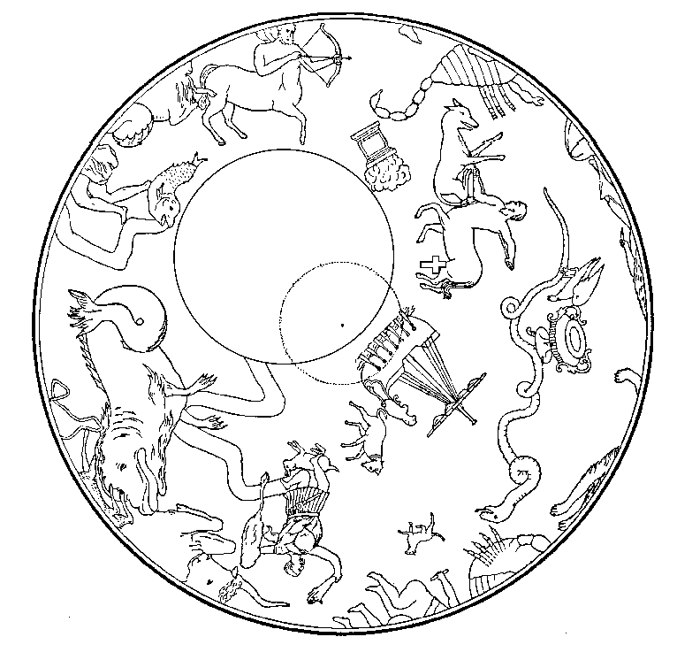

Summer of little rain; no water or food

?

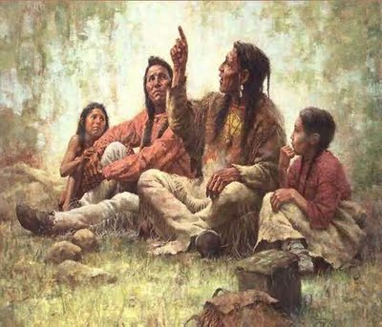

His ashes went into the air and became mosquitoes.

The Oral Tradition of Storytelling

*YouTube video*

Guiding Questions:

1. The video says that, “storytellers were not entertainers, they were __________________ and ________________.
2. Why were stories told?
3. What is a legend?
4. What are 2 animals that are used in some Native American legends?

I can paraphrase information presented through a video.

What does it mean to paraphrase?

* Rewording something that has been spoken or written.
* It is like summarizing.

The video is the text:

* Point of view from Native American Culture

How many times do you think we will need to watch the video to get our information?

Your guess__________

Actual times_________