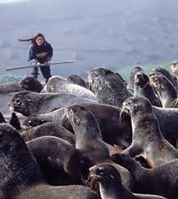

**Seals in Trouble**

**(from Seal Island Kids)**

By Yva Momatuiuk and John Eastcott

Seals were a big part of the lives of Aleut people in the far, far North. Today, many Aleut kids say they’d rather drive ATVs and play computer games than deal with seals. But then some of them found out that the seals needed their help…

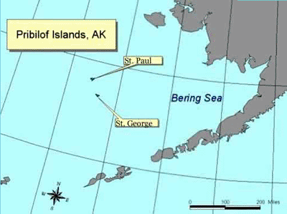“Seals are our brothers.” That is what many Aleut people say. Some Aleuts live on St. Paul Island (see map). It’s one of the Pribilof Islands, near the mainland of Alaska. These people have always depended on northern fur seals for tasty meat and warm clothing.

In the past, Aleut children grew up learning about seals from their parents. During the long winter nights, they listened to the elders telling stories about trips in sea kayaks made from animal skins and bones. The children learned how important the seals were in the lives of their people.

In recent years, many Aleut grownups began to work in offices. Their kids went to school and played computer games at home. Fewer and fewer kids got to know much about their misty island. They seldom watched the thousands of seals or the millions of birds that return to the Pribilof Islands every summer. Some kids drove all-terrain vehicles (ATVs) in ways that damaged the land. Other kids bothered seals or littered the beach.

One day, an Aleut mother named Aquilina Bourdukofsky took a group of kids to the edge of the sea. She showed the kids seals that had scraps of fish net and plastic trash caught around their necks. The scraps and trash hurt and sometimes even killed the seals. The kids were upset to see the harm that people had caused. They asked Aquilina how they could save these animals.

To save the seals, Aquilina thought, the kids would have to learn what scientists were doing to help the animals. But the kids would also have to relearn what their parents and grandparents knew- how to treat nature with respect. So she started a group for the kids called the Pribilof Islands Stewards.

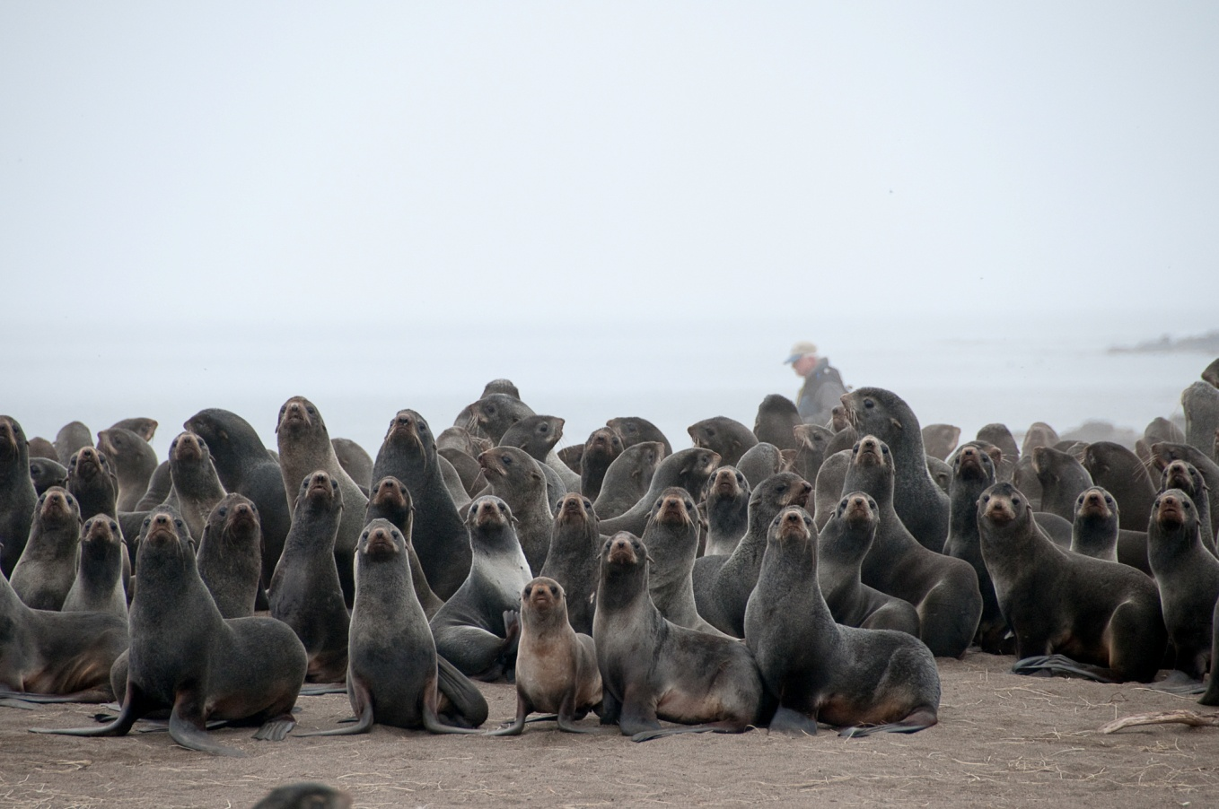

**All About Seals**

Aquilina began by asking scientists such as Bruce Robson to teach the kids about seals. She didn’t have to ask twice. Bruce took the kids to a beach where male seals were hanging out. There, they found more seals that were tangled up in nests and trash.

“Young seals are curious,” Bruce explained. “They love to play with floating things. Sometimes a seal slips its head through a scrap of fish net or a ring of plastic. As the seal grows, the net or plastic gets tighter and slowly strangles the animal.”

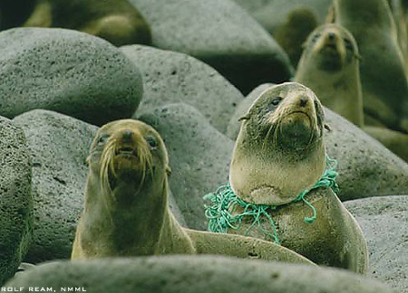

**In this passage, the author describes how Aquilina and her team help seals.**

**Write an original story in which you are a seal requiring help from Aquilina. Be sure to use what you have learned about her team in your story.**

________________________________________________________________________________________________________________________________________________________________________________________________________________________________________________________________________________________________________________________________________________________________________________________________________________________________________________________________________________________________________________________________________________________________________________________________________________________________________________________________________________

______________________________________________________________________________________________________________________________________________________________________________________________________________________________________________________________________________________________________________________________________________________________________________________________________________________________________________________________________________________________________________________________________________________________________________________________________________________________________________________________________________________________________________________________________________________________________________________________________________________________________________________________________________________________________________________________________