1. 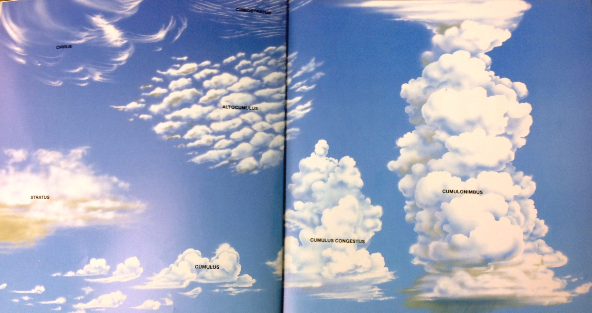Work with a partner.

cumulus congestus

cumulus

cumulonimbus

stratus

altocumulus

cirrostratus

cirrus

1. Look at the clouds very carefully and discuss what you see.
2. Create comparison statements about these clouds.
3. Write your statements on the lines below.

Comparison statements:

1. ____________________________________________________________

______________________________________________________________

2. ____________________________________________________________

_____________________________________________________________

3. ____________________________________________________________

______________________________________________________________