Name:__________________________

Date:___________________________

Staying Safe in a Tornado

From Tornadoes by Seymour Simon

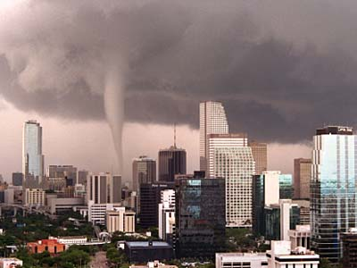Learning about tornadoes can help to save lives. For example, even though the average tornado travels at 30 miles per hour, much faster ground speeds -up to 70 miles per hour- have been reported. That means that trying to flee to safety in an automobile may be reasonable in the country, where the roads are not crowded. But in populated areas, traffic-clogged roads can make it dangerous to get into an automobile.

It is also untrue that tornadoes never strike big cities. For example, Nashville, Tennessee, was badly damaged by a violent tornado in April 1998. And in the past forty years, St. Louis, Missouri has been hit by tornadoes more than twenty times.

Still another myth is that opening the windows in a house will prevent it from being destroyed by a tornado. In fact, opening the wrong windows could allow air to rush in and blow the structure apart from the inside. The best advice is to forget the windows and get to a shelter.

One of the most important things you can do to prevent injury in a tornado is to be alert to the onset of severe weather. Learn the signs of approaching bad weather, so that you will know to tune in the weather forecasts on TV or radio. If a tornado watch is issued for your area, it means that a tornado is possible, or one has already been spotted either on the ground or on radar.

Here are some of the things people hear or see just before a tornado arrives:

* The sky turns a greenish or greenish black color.
* There is a sound a little like rushing air or a waterfall, and it turns into a roar as the tornado comes closer.
* Debris drops from the sky.
* A funnel-shaped cloud appears. It is spinning, while other clouds are moving very quickly toward it.

If a tornado watch or warning is posted, then a real danger sign that a tornado is coming is falling hail.

It is also a good idea to know, *before* a tornado strikes, where to go for shelter. Cars and trailers are *not* safe during a tornado. Go to the basement of a solidly built house. Staying under the stairs or a heave table helps to protect you from crumbling walls. Blankets can also help to shield you from flying debris.

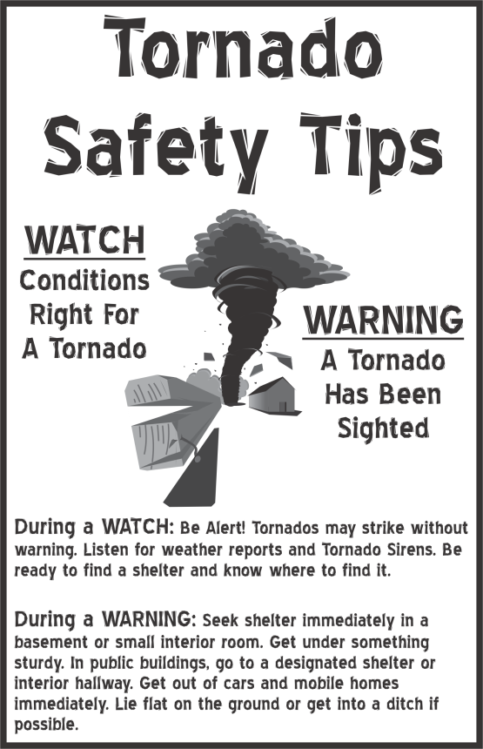 In an apartment or a home without a basement, an inside room or closet is the safest place. Getting into a bathtub and putting a couch cushion over you helps protect you on all sides. Bathtubs are usually solidly anchored to the ground and sometimes are the only thing left in pace after a tornado hits.

If you are walking or biking and are caught in the open when a tornado touches down, lie flat in a ditch or low area if there is *no* rain. If there *is* rain, there may be a danger of flash flooding. Then you should take shelter away from trees and power lines and away from glass windows or doors in houses. Crouch down and make yourself as small a target as possible.

The best protection from tornadoes comes from receiving an early warning. Listening to local radio or television stations during a weather watch can alert you to take safety measures as soon as a tornado warning is broadcast. You don’t have to worry too much in advance about tornadoes, but finding out when they are coming and knowing what to do is certain to help you if one strikes.

1. Why are the words *before* and *no* in italics?

A to show they are titles

B so the reader will stop to think about them

C to emphasize their importance

D so the reader knows to scream those words

2. This passage is most likely intended to

A persuade the reader to study tornadoes

B compare tornadoes and thunderstorms

C teach the reader how to stay safe in a tornado

D tell a story about tornadoes

3. The word flee means

A insect often found on dogs

B get away quickly

C hide

D be safe

4. According to the passage, opening windows during a tornado may-

A keep the windows from shattering

B prevent the house from being destroyed

C allow rain into the house

D cause the structure to blow apart from the inside

5. Which would not be a place to find more information about tornadoes?

A an encyclopedia

B nonfiction section of the library

C a thesaurus

D [www.weather.com](http://www.weather.com)

6. The author uses jot dots (or bullet points) in the passage to

A give the reader a series of steps to follow

B decorate the page

C divide information into subtopics for the reader

D draw attention to important points

7. The main reason the author includes “Tornado Safety Tips” is to

A explain the difference between a watch and a warning

B decorate the page

C show how a tornado moves

D illustrate the passage

The passage says that outrunning a tornado in a storm might not be possible. Why could you not outrun a tornado in a city? Name three ways to stay safe if you are outside during a tornado. Use information from the passage to support your response.

______________________________________________________________________________________________________________________________________________________________________________________________________________________________________________________________________________________________________________________________________________________________________________________________________________________

______________________________________________________________________________________________________________________________________________________________________________________________________________________________________________________________________________________________________________________________________________________________________________________________________________________

______________________________________________________________________________________________________________________________________________________________________________________________________________________________________________________________________________________________________________________________________________________________________________________________________________________