My Father’s Dragon

By Ruth Stiles Gannett

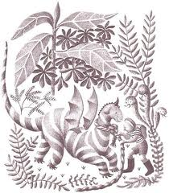

Retold by ______________

Chapter 1

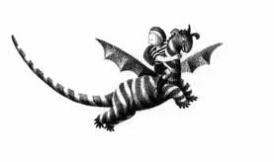



_____________________________________________________________________________________________________________________________

Chapter 10

_____________________________________________________________________________________________________________________________

Chapter 5





_____________________________________________________________________________________________________________________________

Chapter 6

_____________________________________________________________________________________________________________________________

Chapter 7





_____________________________________________________________________________________________________________________________

Chapter 4

_____________________________________________________________________________________________________________________________

Chapter 3





_____________________________________________________________________________________________________________________________

Chapter 8

_____________________________________________________________________________________________________________________________

Chapter 9





_____________________________________________________________________________________________________________________________

Chapter 2

_____________________________________________________________________________________________________________________________

Map of

The Island of

Tangerina and

Wild Island

the Characters

|  |
| --- |
| Wild Boar |
| Tigers |
| Rhino |
| Lion |
| Gorilla |
| Dragon |

Meet

|  |
| --- |
| Jim |
| Mom |
| Elmer |
| Cat |
| Captain |
| Mouse |



