**Before the Lesson:**

Before engaging students in the text-dependent questions, provide students with a copy of the text as well as a basic story map. Have students read the story independently and fill in as many blanks on the story map as possible. Encourage students make notes of any unfamiliar words either by underlining the word in the text of making a note in the margin. Remind students to not let the names of the characters keep them from reading through the story. Teachers can either discuss names ahead of time or remind students to call characters by their first initial, such as T, A, King M, etc.

After providing time for students to read the story independently, consider reading it aloud for only those students reading a grade level or more below what is expected at this point in the year. Be careful not to discuss the story. Simply read it aloud.

**During the Lesson:**

Begin by rereading the text. Consider having students whisper read while the teacher or a strong reader reads aloud. This will reinforce strong fluency skills.

After reading the text, ask students which vocabulary words were the most confusing. Allow students to share a word or phrase they noted. Give the rest of the class an opportunity to share their thoughts on what the word or phrase means. If students are unable to tell the definition, give students enough information to make sense of the story. Do not stop to dwell on specific words at this time. Instead, consider noting these words and returning to them for specific vocabulary instruction at a later time.

**After the Lesson:**

Provide students with a second copy of the Character Traits Map. Have students work independently to complete the story map analyzing Theseus. This can be used as a formative assessment to measure RL.3.3.

**Standards addressed through the text dependent questions:**

RL.3.1 Ask and answer questions to demonstrate understanding of a text, referring explicitly to the text as the basis for the answers

RL.3.2 Recount stories, including fables, folktales, and myths from diverse cultures; determine the central message, lesson, or moral and explain how it is conveyed through key details in the text.

**RL.3.3 Describe characters in a story (e.g., their traits, motivations, or feelings) and explain how their actions contribute to the sequence of events.**

RL.3.4 Determine the meaning of words and phrases as they are used in a text, distinguishing literal from non-literal language.

**Text-Dependent Questions**

1. According to paragraph 2, what did the King of Athens want to do to King Minos? What does this phrase mean? Why did the King of Athens want to do this?

* The text says that the King of Athens wanted to “send King Minos Packing.” This means that he wanted to send Minos back to Crete without attacking the city and people of Athens.
* The King of Athens was tired of King Minos coming to attack his city and its people. He knew that he did not have a navy strong enough to defeat King Minos. He felt that if he had time to truly create a strong navy, he could protect the city from King Minos.

1. In paragraph 4, what made the people of Athens cry? Using this information, what character traits could be used to describe the people of Athens?

* In paragraph 4, the people of Athens were crying because they knew it was time to send 7 boys and 7 girls to Crete for the Minotaur to eat. This was the deal made between the King of Athens and King Minos.
* The people of Athens were compassionate, depressed, distraught, worried, inconsolable, etc.

1. What tools did Ariadne tell Theseus to hide at the entrance to the maze? What was the purpose of each item?

* Ariadne gave Theseus a sword so that he could kill the Minotaur.
* Ariadne gave Theseus a ball of string. She told him to tie the end of the string to the entrance to the maze and unroll it as he searched for the Minotaur. After killing the Minotaur he could follow the string back to the entrance to the maze.

1. What does *admire* mean as it is used in the last paragraph? Why would the people on the island of Naxos *admire* her? Use specific details from the text to support your response.

* In her letter to Theseus, Ariadne told Theseus that he should take her away from Crete, “…so that others can admire my beauty.”

1. What word from paragraph 13 is a synonym for *admire*?

* In paragraph 13, Ariadne says that she should go with Theseus so that other people can *marvel* at her beauty. *Marvel* and *admire* are synonyms.

1. What was the deal Theseus made to Ariadne? Did he honor this deal? Did the deal go as Ariadne had planned? Explain your thinking using evidence from the passage.

* Theseus agreed to take Ariadne away from Crete if she helped him to defeat the Minotaur.
* Yes, Theseus honored the deal. He took Ariadne away from Crete.
* No, the deal did not go as planned. Ariadne expected Theseus to take her with him, which he did, but he left her on the island of Naxos instead of taking her with him to Athens.

1. What central message can be found in “Theseus and the Minotaur? What lesson (or lessons) would the Ancient Greeks have learned by reading “Theseus and the Minotaur”? Use details from the text to support your response.
   * Student responses to this question will vary. Accept any answer for which students can provide accurate evidence to support.
   * Possible student answers include, but are not limited to:
     1. If you make a deal with someone, you must honor it…even if it is a bad deal. (Theseus took Ariadne with him when he left Crete even though she annoyed him by talking about her beauty.)
     2. Be kind to others so they will be kind to you. (Ariadne wanted to leave Crete, so she helped Theseus kill the Minotaur. He then took her away from Crete.)
     3. Don’t brag about being beautiful; it annoys people. (Even though Theseus DID take Ariadne away from Crete, he left her on the island of Naxos instead of taking her with him back to Athens.)
2. Describe Ariadne from the story. Use feelings, actions, words, and thoughts from the text to support your description. (Hint: Be sure to tell about inside characteristics/traits.) Provide students with a Character Traits Map in order to track their thinking.
3. Describe Theseus from the story. Use feelings, actions, words, and thoughts from the text to support your description. (Hint: Be sure to tell about inside characteristics/traits.) Provide students with a second copy of the character traits map. Analyzing Theseus could be done whole class, with a partner, or independently.

“Theseus and the Minotaur”

from greece.mrdonn.org

Once upon a time, a long time ago, there lived a king named Minos. King Minos lived on a lovely island called Crete. King Minos had everything a king could possibly want. Now and then, King Minos sent his navy to the tiny village of Athens, across the sea.

The king of Athens did not know what to do. He was desperate. He figured if he had some time, he could build a strong navy, strong enough to send King Minos packing the next time he attacked Athens. The king of Athens offered King Minos a deal. If he would not attack Athens for 9 years, Athens would send 7 boys and 7 girls to the island of Crete to be eaten by the awful monster that King Minos kept as a pet, the dreaded minotaur.

2

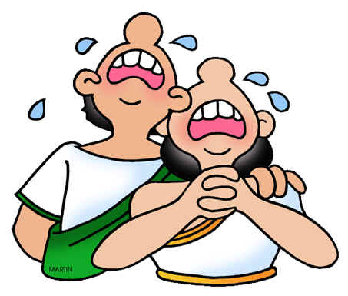The minotaur lived in the heart of a maze on the island of Crete. King Minos loved that old monster. King Minos only attacked Athens when he was bored. He really didn't want anything. This way, his beloved monster could look forward to a special treat every 9 years or so. King Minos took the deal.

Although Athens did build a navy, King Minos did not attack as the king of Athens had expected. In fact, King Minos kept his word. And now it was time for Athens to keep theirs.  Everyone in Athens was crying.

Prince Theseus of Athens knew the importance of keeping your word. He knew that a deal was a deal. But, he was also quite sure that it was wrong to send small children to be eaten by a monster. Prince Theseus told his father (the king) that he was going to Crete as the seventh son of Athens. He was going to kill the Minotaur and end the terror.

"The Minotaur is a terrible monster! What makes you think you can kill it?" cried his father.

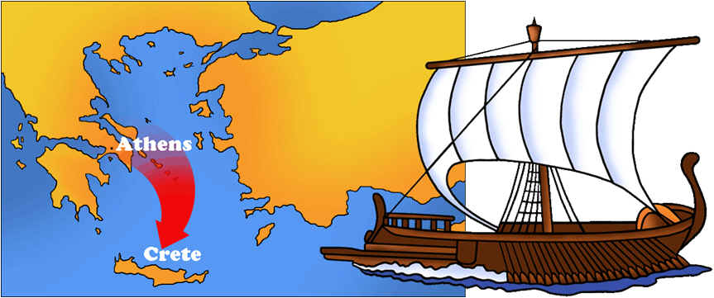"I'll find a way," Theseus replied gently. "The gods will help me."

His father begged him not to go. But the prince took his place as the seventh Athenian boy. Along with six other Athenian boys and seven Athenian girls, Prince Theseus sailed towards Crete.

When the prince and the children arrived on the island of Crete, King Minos and his daughter, the Princess Ariadne, came out to greet them. The Princess Ariadne did not say anything. But her eyes narrowed thoughtfully. Late that night, she wrote Prince Theseus a note and slipped it under his bedroom door.

***Dear Theseus (Ariadne wrote)***

***I am a beautiful princess as you probably noticed the minute you saw me. I am also a very bored princess. Without my help, the Minotaur will surely gobble you up. I know a trick or two that will save your life. If I help you kill the monster, you must promise to take me away from this tiny island so that others can admire my beauty. If interested in this deal, meet me by the gate to the Labyrinth in one hour.***

***Yours very truly,   
Princess Ariadne***

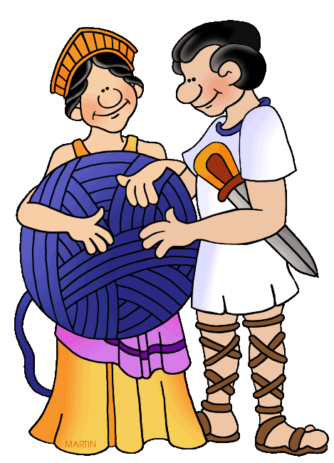Prince Theseus slipped out of the palace and waited patiently by the gate. Princess Ariadne finally showed up. In her hands, she carried a sword and a ball of string.

Ariadne gave the sword and the ball of string to Prince Theseus. "Hide these inside the entrance to the maze. Tomorrow, when you and the other children from Athens enter the Labyrinth, wait until the gate is closed, then tie the string to the door. Unroll it as you move through the maze. That way, you can find your way back again. The sword, well, you know what to do with the sword," she laughed.

Theseus thanked the princess for her kindness.

"Don't forget, now," she cautioned Theseus. "You must take me with you so that all the people can marvel at my beauty."

14

The next morning, the Athenian children, including Prince Theseus, were shoved into the maze. The door was locked firmly behind them. Following Ariadne's directions, Theseus tied one end of the string to the door. He told the children to stay by the door and to make sure the string stayed tied so the prince could find his way back again. The children hung on to the string tightly, as Theseus entered the maze alone.

Using the sword Ariadne had given him, Theseus killed the monstrous beast. He followed the string back and knocked on the door.

Princess Ariadne was waiting. She opened the door. Without anyone noticing, Prince Theseus and the children of Athens ran to their ship and sailed quietly away. Princess Ariadne sailed away with them.

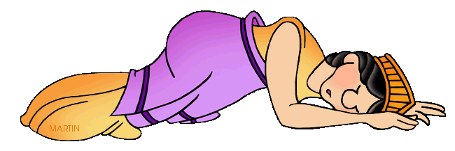On the way home, they stopped for supplies on the tiny island of Naxos. Princess Ariadne insisted on coming ashore. There was nothing much to do on the island. Soon, she fell asleep. All the people gathered to admire the sleeping princess. Theseus sailed quietly away with the children of Athens and left her there, sleeping.

After all, a deal is a deal.