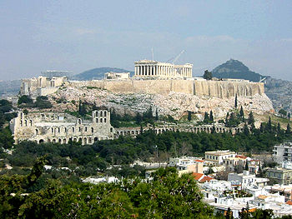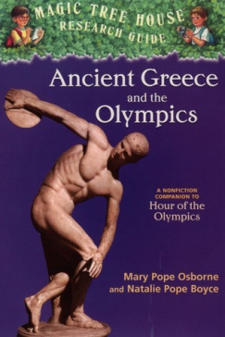

Fact Tracker

**Ancient Greece**

**What:**

**___________________________________________________________________________________________________________________________________________________________________________________________________________________________________________________________________________________________________________________________________________________________________________________________________________________________________________________________________________________________________________________________________________________________________________________________________________________________________________________________________________________________________________________________________________________________________________________________________________________________________________________________________________________________________________________________________________________________________________________________________________________________________________________________________________________________________________________________________________________________________________________________________________________________________________________________________________________________________________________________________________________________________________________________________________________________________________________________________________________________________________________________________________________________________________________________________________________________________________________________________________________________________________________________________________________________________________________________________________________________________________________________________________________________________________________________________________________________________**

The people of Athens and Sparta were very different. Give evidence of these differences.

The author said Athens had one of the first democratic governments in the world. People run the government, not kings. Give evidence of who could vote in Athens.

**When:**

**Where:**



**Describe what you would do to dress like a Greek. Support your answer with evidence from the text.**

**agora**

**tunic**

**Aqueducts**

Give a short description of the following places and things.

**________________________________________________________________________________________________________________________________________________________________________________________________________________________________________________________________________________________________________________________________________________________________________________________________________________________________________**

**How would you spend time in ancient Greece? Support your answer with evidence from the text starting on page 47.**



**One Greek poet called olive oil “liquid gold”. Why were olive trees such a big deal to this culture? Use evidence from the text. Pg.54**

**The author tells us on page 57 that the ideas and works of ancient Greece still inspire us today. In what areas has this culture shaped our culture today?**

**________________________________________________________________________________________________________________________________________________________________________________________________________________________________________________________________________________________________________________________________________________________________________________________________________________________________________________________________________________________________________**