**Day 1 Chapter 1 - New Information and Application.** I think you could read, answer the questions, and then take notes based on the correct answers. The right side will be for the note taking and the left side will be for choosing their answer and a short writing prompt that goes with the reading. (Just project this on the screen.)

**Question 1.** Answer after reading through page 7, take notes in notebook AFTER the question is answered correctly.

**Part A**

What does the word **immigrants** mean as it is used in paragraph 1 of chapter 1?

1. Ships
2. Goods
3. People
4. Something special

**Part B**

Which statement **best** supports the answer to part A?

1. “Ships came in from around the world.”
2. “Some ships carried goods.”
3. “Others carried something special.”
4. “These men, women, and children came…”

**Question 2.** After reading page 8, then take notes on the correct answers.

Complete the chart to show why the immigrants came to America. Pick all reasons that apply. (On PARCC this would be a drag and drop)

|  |
| --- |
| **Reasons why People Came** |
|  |
|  |
|  |
|  |

Reasons why People Came

* To escape poverty.
* To escape the harsh winters in their countries.
* They wanted a better life.
* They heard you could become rich in the United States if you work hard.
* They wanted to be with family.
* To have more religious freedom.

Name it Claim it: The main idea of chapter 1 is _______________________.

*This is more for typing and thought practice. Not necessarily how PARCC will ask it. They would ask it in a m/c format.

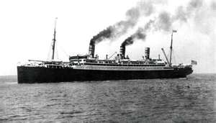 **Chapter 2: A Difficult Trip**

Deciding to leave home was the first part of a long, hard journey. People who leave their country to live in a new place are called **emigrants**. Most emigrants came to the United States on **steamships**. The trip across the Atlantic Ocean was long, and most people did not travel in style.

***On some trips to the United States,***

***many passengers didn’t survive.***

**Before Leaving**

The first step was to buy a ticket for passage across the ocean on a ship. Many emigrants bought their tickets from salesmen who traveled from town to town throughout Europe. The cheapest tickets cost around $30. That would be more than $700 today. It was a huge purchase for someone who barely had money for food.

Until 1900, immigrants to the United States just needed a ticket. After 1900, they also needed a passport and a document called a **visa**. A visa gives someone permission to enter a country. U.S. offices located in other countries gave out visas.

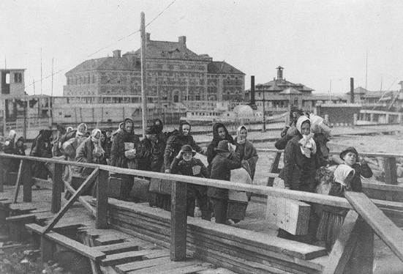 After buying a ticket, people had to travel from their towns to a **port** city. A port city has a place for ships to dock. Many people walked with all their belongings. The lucky ones took a train to the ship. Still others rode on horseback or in a wagon.

Once they arrived at the port, emigrants had to wait days, weeks, or even months for the ship to arrive. Steamship companies often agreed to provide housing for ticket holders while they waited.

The steamship companies hired doctors to examine all the passengers. Any person with an illness was turned away. Emigrants were given shots to prevent disease. They often took disinfecting baths to kill germs. Only then were they allowed to board a ship.

**Traveling in Steerage**

Steerage was the area near the ship’s bottom. It was close to the steering equipment. The cheapest tickets were in steerage. Passengers climbed down steep stairways to get there. As many as 2,000 passengers crowded together.

The steerage area was dark and unclean. There was little fresh air. There weren’t enough washrooms either. The smell was hard to bear. Yet people were willing to travel this way to get to the

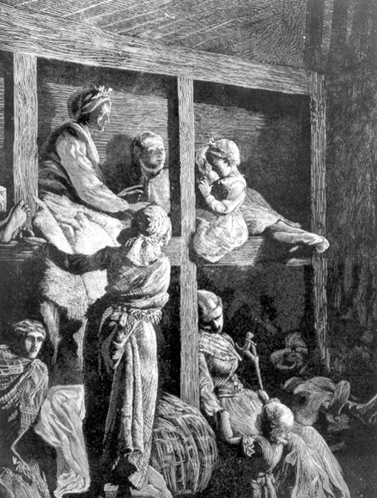United States.

**The Steerage Class**

Take a close look at the life in the steerage section of a ship-if you can stand it.

* A passenger and his belongings had to fit in a narrow bunk.
* Mattresses were filled with straw or seaweed.
* Floors were often covered in dirt and vomit.
* As many as 300 passengers shared two bathrooms.
* Passengers ate small portions of bread, potatoes, and meat, scooped from large kettles.
* What did passengers do all day? They played cards, sang, danced, told stories, and practiced English.

**Questions for chapter 2: *A Difficult Trip*, 1st read of close reading.** *(See annotated page for Mrs. Trombley’s marks.)*

**Vocab to discuss with this passage: I would ask…what does the word ____ mean? How do you know?**

**Emigrants**- context clues-have them write, underline, highlight or orally tell the sentence with the context clue.

**Visa**-context clues-have them write, underline, highlight or orally tell the sentence with the context clue.

**Port**- context clues-have them write, underline, highlight or orally tell the sentence with the context clue.

**Part A:** The article includes these details about the difficult trip:

* Tickets were very expensive and most of the people who bought them had little money even for food.
* They had to travel to a port city and wait for days or weeks to board a steamship.
* They had to go through a medical checkup and if they were found ill they were turned away.
* The cheapest tickets were in steerage which was at the bottom of the ship and very crowded and unclean.

**What do these details help show us about the dream of coming to America?**

1. They show us that the trip could be taken by anyone?
2. They show us that even though it cost a lot of money, time, and was difficult people were still willing to go through the hardship to get to America.
3. They show us that the trip was really only for the rich and healthy.
4. They show us that it took a lot of planning to come to America.

**Part B**: Ideas from the text were used to help you summarize the passage, ***A Difficult Trip***. Go back to the passage and highlight (or underline) 2 more details that support your answer to part A. Then bring those details down and write them in the table. (On the PARCC test the students will have to go back and highlight the details. It will not let them highlight anything that has already been used in the previous question.)

|  |
| --- |
|  |
| *\*Continue with this passage in small group for close reading day 2 & 3. See plans for that at the end.* |

**Questions for chapter 3: *Why Ellis Island*?**

**Question 1:**

**Part A:** Which statement best describes how the events in chapter 3 are related to each other?

1. They describe why immigrants came to the United States.
2. They explain the chronological timeline of Ellis Island.
3. They compare the old Ellis Island to the new one.
4. They show why Ellis Island was needed.

**Part B:** Which statement from the article best supports the answer in Part A?

1. “They were all looking for a better life.”
2. “The two-story Ellis Island Immigration Station opened on January 1, 1892.”
3. “By 1900, a new and improved brick building had been built and was open for business.”
4. “In time, it was clear that Castle Garden could not handle all the immigrants arriving in New York.”

**Question 2:**

Where did Ellis Island get its name? (Use your name it and claim it to answer)

**Question 3:**

Based on the section, “***Getting Around the Island***”, would you agree with the following claim,

“Getting through Ellis Island was a quick process.” Create an Argument to support your answer with details from that section only.

**Prompt for chapter 4: *On American Soil, at Last!***

This chapter describes the process an immigrant had to go through once they reached Ellis Island. Write a journal entry from the eyes of a steerage passenger. Include information about what you had to go through based on the details in the chapter.

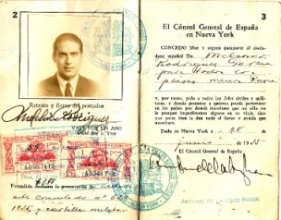

**Chapter 5: After Ellis Island**

For a time, Ellis Island was crowded and busy. But things began to change in the 1920’s. Americans started having trouble finding jobs. Some blamed immigrants for taking too many of the jobs. Immigrants were blamed for other problems in the country, too. The United States became a less welcoming place.

***New immigration laws made it hard for people from Poland and other countries to enter the United States.***

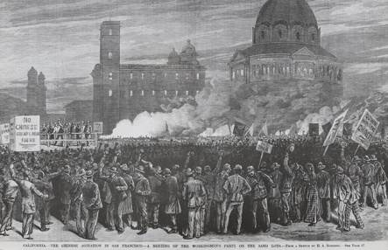**Fewer and Fewer**

Some Americans began to treat immigrants unfairly. They **discriminated** against immigrants from certain places, including eastern and southern Europe.

The U.S. government passed laws to limit immigration. The 1921 Emergency **Quota** Act set a fixed number, or quota, of immigrants. Each country could send only a certain number of people each year. The law’s main purpose was to limit the flow of immigrants from eastern and southern Europe. Steamships packed with immigrants were turned away. Steamships packed with immigrants were turned away. This chart shows the act’s effects on immigration.

***Americans have discriminated against different immigrants at different times in history. Workers at this 1879 meeting in San Francisco, California, protest against Chinese immigrant workers.***

|  |  |  |
| --- | --- | --- |
| **Number of Immigrants Each Year** | | |
|  | **Before 1921 Act** | **After 1921 Act** |
| **From northern and western Europe** | 176,983 | 198,082 |
| **From other countries, mostly southern and eastern Europe** | 685,531 | 158,367 |

Anti-immigrant feelings continued to grow. Unfair laws were passed that kept out Jewish people and Catholics. (These laws were later changed.) The U.S. government lowered immigration quotas again in 1929.

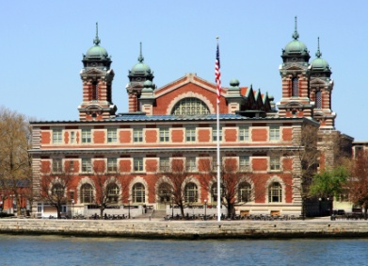 By the 1950’s, only a few dozen immigrants were coming through Ellis Island each year. The government no longer needed the Ellis Island Immigration Station. It closed its doors in 1954. President Lyndon Johnson made it a national monument in 1965. But still the buildings lay deserted and began to fall apart.

In the 1980’s, a group called the Statue of Liberty-Ellis Island Foundation worked hard to restore the buildings on Ellis Island. The main building reopened on September 10, 1990. It cost $160 million to repair.

It is now called the Ellis Island Immigration Museum. Two million people visit the museum each year. Its exhibits tell the story of U.S. immigration.

More than 100 million Americans today have relatives who passed through Ellis Island. You may be one of them. These immigrants went through a lot to get here! They took a big risk for the promise of a better future. In the end, many found the American dream they were looking for.

**Questions for chapter 5: *After Ellis Island*?**

**Question #1**

**Part A**

What does the word **discriminated** mean as it is used in sentence 2 under the heading ***Fewer and Fewer?***

1. To dislike
2. To make feel unwelcome
3. To be unfair
4. To pass laws against

**Part B**

Which statement best supports the answer to part A?

1. “Some blamed immigrants for taking too many of the jobs.”
2. “The United States became a less welcoming place.”
3. “Some Americans began to treat immigrants unfairly.”
4. “The U.S. government passed laws to limit immigration.”

**Question #2**

**Part A**

Which statement provides the **best** explanation based on the information found in the chart, *Number of Immigrants Each Year*?

1. There were more immigrants from northern and western Europe before the 1921 Act was passed.
2. There were fewer immigrants from northern and western Europe after the 1921 act.
3. There were more immigrants from other countries, mostly southern and eastern Europe before the 1921 Act.
4. There were more immigrants from southern and eastern Europe than northern and western Europe after the 1921 Act.

**Part B**

Which sentence from *“After Ellis Island”* best supports the answer to part A?

1. “Some Americans began to treat immigrants unfairly.”
2. “The 1921 Emergency Quota Act set a fixed number, or quota, of immigrants.”
3. “The law’s main purpose was to limit the flow of immigrants from eastern and southern Europe.”
4. “Steamships packed with immigrants were turned away.”

**Question #3**

Using the statements found below the chart from Chapter 5**,** Match the correct cause with the correct effect. Drag and drop so the correct cause is first and the effect is second.

Anti-immigrant feelings continued to grow.

Unfair laws were passed that kept out Jewish people and Catholics.

More that 100 million Americans today have relatives who passed through Ellis Island.

By the 1950’s, only a few dozen immigrants were coming through Ellis Island each year.

These immigrants went through a lot to get here and took a big risk for the promise of a better future.

In the 1980’s, a group called the Statue of Liberty-Ellis Island Foundation worked hard to restore the buildings on Ellis Island.

The main building reopened on September 10, 1990. Today it is a national monument that two million people visit each year.

The government no longer needed the Ellis Island Immigration Station and closed its doors in 1954.

|  |  |
| --- | --- |
| **Cause** | **Effect** |
|  |  |
|  |  |
|  |  |
|  |  |