Name:___________________________________________ Date:____________________________

14 Cows by Wilson Kimeli Naiyomah and Carmen Agra Deedy

Study this picture below:

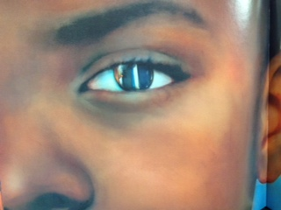

Read and think about the text written below from the story 14 Cows.

“Because there is no nation so powerful it cannot be wounded, nor a people so small they cannot offer mighty comfort.”

1. How does the illustration within the eye support the text, “no nation so powerful it cannot be wounded”? What nation is the author talking about? How was our nation wounded?

____________________________________________________________________________________________________________________________________________________________________________________________________________________________________________________________________________________________________________________________________________________

1. Read the second part of the sentence, “nor a people so small they cannot offer might comfort”.

Who is the author talking about and what comfort did they bring?

____________________________________________________________________________________________________________________________________________________________________________________________________________________________________________________________________________________________________________________________________________________

1. In working together, how do the text and illustration create the main idea of this story?

____________________________________________________________________________________________________________________________________________________________________________________________________________________________________________________________________________________________________________________________________________________