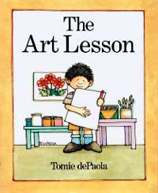

Tommy wants to be an artist when he grows up. Read this excerpt from The Art Lesson by Tomie DePaola to learn about his first art lesson.

The classroom door opened and in walked the art teacher. Miss Landers said, “Class this is Mrs. Bowers, the art teacher. Patty, who is our paper monitor this week, will give out one piece of paper to each of you. And remember, don’t ruin it because it is the only piece you’ll get. Now, pay attention to Mrs. Bowers.

“Class,” Mrs. Bowers began, “because Thanksgiving is not too far away, we will learn to draw a Pilgrim man, a Pilgrim woman and a turkey. Watch carefully and copy me.”

Copy? COPY? Tommy knew that real artists didn’t copy.

This was terrible. This was supposed to be a real art lesson. He folded his arms and just sat there. “Now what’s the matter?” Miss Landers asked. Tommy looked past her and spoke right to Mrs. Bowers.

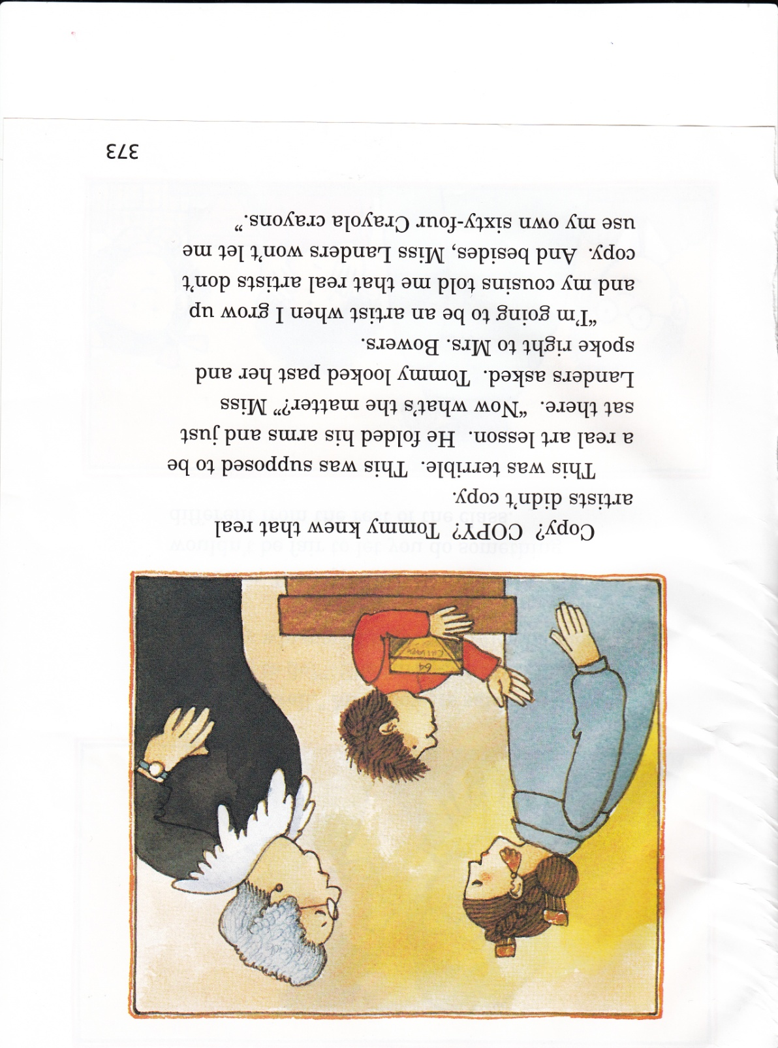

“I’m going to be an artist when I grow up and my cousins told me that real artists don’t copy. And besides, Miss Landers won’t let me use my own sixty-four Crayola crayons.”

“Well, well,” Mrs. Bowers said. “What are we going to do?”  
 She turned to Miss Landers and they whispered together. Miss Landers nodded.

“Now, Tommy,” Mrs. Bowers said. “It wouldn’t be fair to let you do something different from the rest of the class.

“But I have an idea. If you draw the Pilgrim man and woman and turkey, and if there’s any time left, I’ll give you another piece of paper and you can do your own picture with your own crayons. Can you do that?

“I’ll try,” Tommy said, with a big smile.

And he did.

And he did.

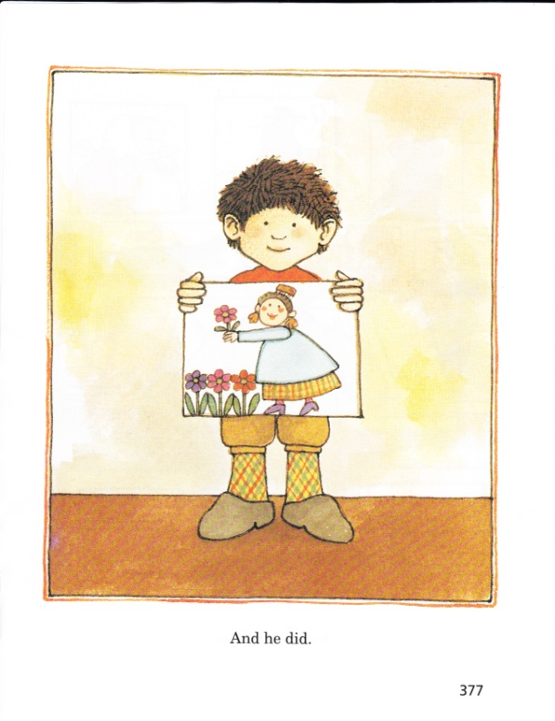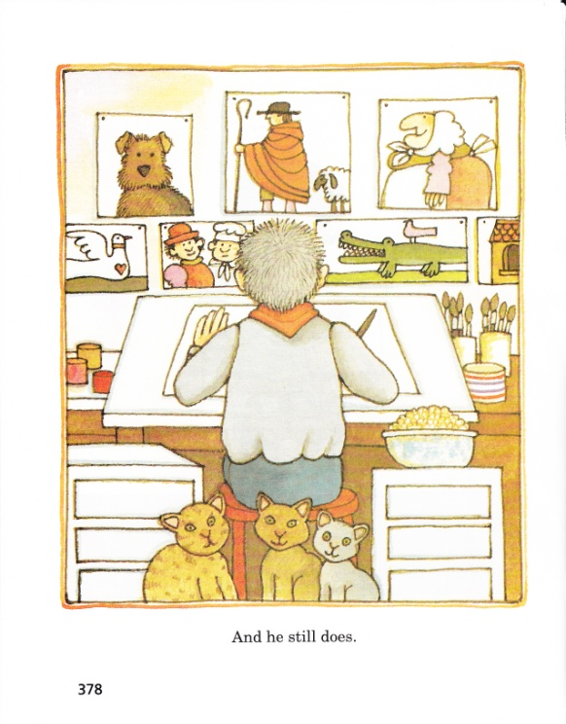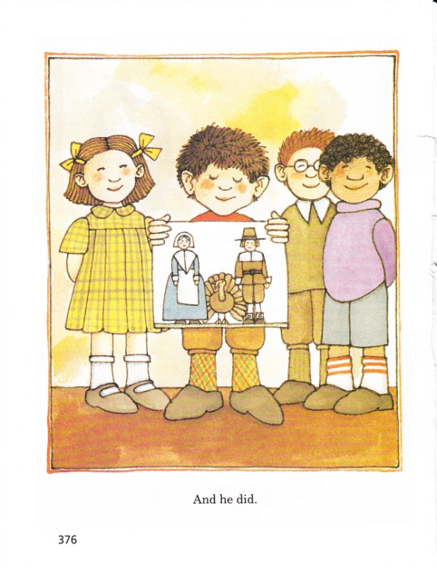And he still does.

In this story, the author describes Tommy’s first art lesson. Use what you have learned from the story to write an original story describing Tommy’s second art lesson.

________________________________________________________________________________________________________________________________________________________________________________________________________________________________________________________________________________________________________________________________________________________________________________________________________________________________________________________________________________________________________________________________________________________________________________________________________________________________________________________________________________

_____________________________________________________________________________________________________________________________________________________________________________________________________________________________________________________________________________________________________________________________________________________________________________________________________________________________________________________________________________________________________________________________________________________________________________________________________________________________________________________________________________________________________________________________________________________________________________________________________________________________________________________________________________________________