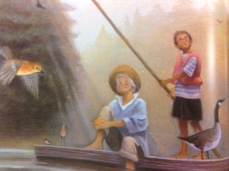Name:__________________________________ Date:____________________________________

After supper, I showed Grandma my drawing of the fawn and told her my story.

“It’s perfect,” she said, “but we need to do one more thing.” She hurried up to the cottage. When she came back, she had tubes of oil paint and two brushes.

Grandma helped me trace my drawing with the oil paint, which soaked deep into the wood. “That’ll keep it,” she said. “Now you’ll always be part of the river.”

“Just like you, Grandma,” I told her. “A river rat.”

“Grandma laughed. “Just like me,” she agreed.

1. Whose point of view is the story written from?

____________________________________________________________

1. How does it shape the story?

____________________________________________________________

______________________________________________________________

1. How would the story be different if it was told from the grandma’s point of view?_________________________________________________________

__________________________________________________________________________________________________________________________