Prior to this lesson: Students should have learned to recount stories, identify plot, and know the steps of comparing and contrasting.
STANDARDS | RL.3.9 Compare and contrast plots of stories written by the same author about similar characters
Lesson Structure | High Yield Strategies |  | Lesson Plan
Goal  (2 minutes) | (8) Setting Objective and Providing Feedback  (4) Reinforcing effort and Providing Recognition |  | I can compare and contrast the plots of stories written by the same author  *Have students interact with the goal.
Access Prior Knowledge  (3minutes) | (6) Nonlinguistic Representations  (7) Cooperative Learning  (10) Cues, Questions and Advance Organizers |  | Have students look at their comparison matrix. Turn and talk about the plot of Tea with Milk.  Students can use the following sentence stem when they turn and talk, “In the beginning (middle, end) of Tea with Milk, May________________________________________.”
New Information | (3) Summarizing and Note Taking  (5) Homework and Practice  (11) Teaching Specific Types of Knowledge |  | Pair students to highlight/underline the parts of the two stories that were the same.  Students can use the following sentence stems as they discuss, “The plots are the same because _______________________.”  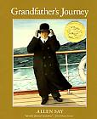  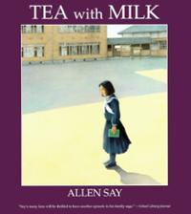  “The plots are different because _______________________.”
Application | Declarative  (2) Indentifying Similarities and Differences  (3)Generating and Testing Hypotheses  (10) Cues, Questions and Advance Organizers | Procedural  (5) Homework and Practice | Students independently write the similarities and differences of the two stories on page 2 of their matrix.
Goal | (8) Setting Objective and Providing Feedback  (4) Reinforcing effort and Providing Recognition |  | I can compare and contrast the plots of stories written by the same author  Have students share out what similarities and differences they noticed.
Grade: 3rd Subject: Reading

