from Through Grandpa’s Eyes

by Patricia MacLachlan

Of all the houses that I know, I like my grandpa’s best. My friend Peter has a new glass house with pebble-path gardens that go nowhere. And Maggie lives next door in an old wooden house with rooms behind rooms, all with carved doors and brass doorknobs. They are fine houses. But Grandpa’s house is my favorite. Because I see it through Grandpa’s eyes.

Grandpa is blind. He doesn’t see the house the way I do. He has his own way of seeing.

In the morning, the sun pushes through the curtains into my eyes. I burrow down into the covers to get away, but the light follows me. I give up, throw back the covers, and run to Grandpa’s room.

The sun wakes Grandpa differently from the way it wakes me. He says it touches him, *warming* him awake. When I peek around the door, Grandpa is already up and doing his morning exercises. Bending and stretching by the bed. He stops and smiles because he hears me.

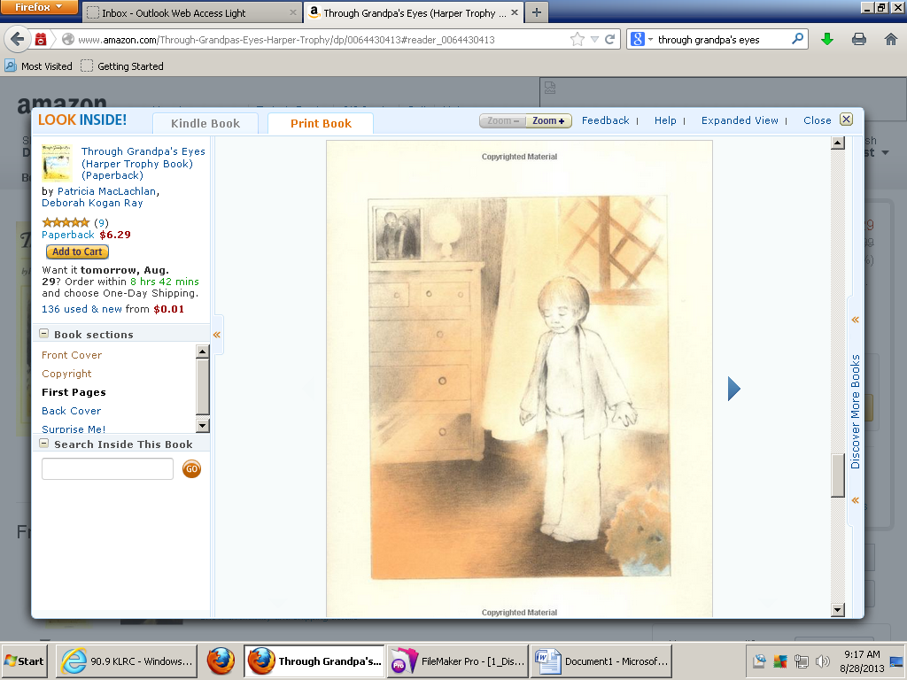

“Good morning, John.”

“Where’s Nana?” I ask him.

“Don’t you know?” he says, bending and stretching. “Close your eyes, John, and look through my eyes.”

I close my eyes. Down below, I hear the banging of posts and the sound of water running that I didn’t hear before.

“Nana is in the kitchen, making breakfast,” I say.

When I open my eyes again, I can see Grandpa nodding at me. He is tall with gray hair. And his eyes are sharp blue even though they are not sharp seeing.

from Through Grandpa’s Eyes

by Patricia MacLachlan

Of all the houses that I know, I like my grandpa’s best. My friend Peter has a new glass house with pebble-path gardens that go nowhere. And Maggie lives next door in an old wooden house with rooms behind rooms, all with carved doors and brass doorknobs. They are fine houses. But Grandpa’s house is my favorite. Because I see it through Grandpa’s eyes.

Why does the author tell us about Peter and Maggie’s houses? Do we need to remember those details?

If grandpa is blind, how does he *see*?

Grandpa is blind. He doesn’t see the house the way I do. He has his own way of seeing.

In the morning, the sun pushes through the curtains into my eyes. I burrow down into the covers to get away, but the light follows me. I give up, throw back the covers, and run to Grandpa’s room.

How does John feel when he first wakes up? How do you know? How do his feelings change?

What kind of exercises could grandpa be doing? How do you know? (thinking about the space he has if he is stretching and exercising beside the bed.

The sun wakes Grandpa differently from the way it wakes me. He says it touches him, *warming* him awake. When I peek around the door, Grandpa is already up and doing his morning exercises. Bending and stretching by the bed. He stops and smiles because he hears me.



“Good morning, John.”

How does grandpa *see* the house?

“Where’s Nana?” I ask him.

“Don’t you know?” he says, bending and stretching. “Close your eyes, John, and look through my eyes.”

What happens when John looks through grandpa’s eyes?

I close my eyes. Down below, I hear the banging of posts and the sound of water running that I didn’t hear before.

“Nana is in the kitchen, making breakfast,” I say.

How does John know that Nana is cooking breakfast?

When I open my eyes again, I can see Grandpa nodding at me. He is tall with gray hair. And his eyes are sharp blue even though they are not sharp seeing.

Why do you think John likes Grandpa’s house more than others?

If students have already read Grandfather’s Journey and/or Knots on a Counting Rope, make comparisons to those texts…characters, first few pages, settings, etc.