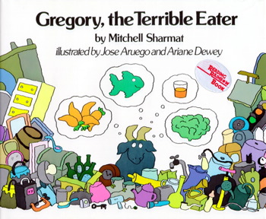Name ______________________

Date ________________

***Text Dependent Questions for***

***Gregory the Terrible Eater***

Use the book to answer the questions. Be sure to cite evidence from the text.

1. What does the word “***average***” mean on pages 1 and 2?

__________________________________________________________________________________________________________

1. What details from the story tell you that Gregory **wasn’t** an *average* goat?

__________________________________________________________________________________________________________

1. What does the phrase “this is a meal fit for a goat” mean?

__________________________________________________________________________________________________________

1. What evidence from the text helped you know the meaning of “this is a meal fit for a goat”?

__________________________________________________________________________________________________________

1. How do you think Gregory felt when his parents offered him the coat and pants for breakfast?

__________________________________________________________________________________________________________

1. Why did he leave the table?

__________________________________________________________________________________________________________

1. What does Dr. Ram suggest mother and father do to help Gregory develop a taste for good food?

__________________________________________________________________________________________________________

1. What did mother goat mean when she said, “It’s alright to eat like a goat, but you shouldn’t eat like a pig.”?

__________________________________________________________________________________________________________

1. How did Gregory sleep after eating his supper from the dump?

__________________________________________________________________________________________________________

1. What words from the text support your thinking about how he slept that night?

__________________________________________________________________________________________________________