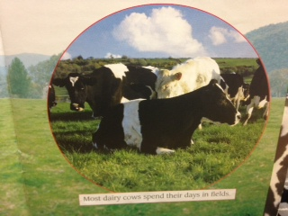From Cow to Milk Carton

By Annie Miles

Dairy cows are amazing animals. They eat up to 154 pounds of grass a day and use it to make about 32 pints of milk. For a dairy cow to make mild she must first have a calf. After a dairy cow has had a calf she can make mild for up to ten months. Many things happen to this milk before you buy it. Many people work to get the milk from the cow to the milk carton.

The cow spends most of her time eating. She tears off grass with her tongue. The cow swallows the grass without chewing it. A cow’s stomach has four parts. The unchewed grass goes into the first two parts of the cow’s stomach. The cow’s stomach makes the grass into balls about the size of tennis balls. The balls are called cud.

When the cow has finished eating grass, she brings the cud up into her mouth, one ball at a time. She chews the cud again to break it down. The cow then swallows the cud, but this time it goes into the third part of her stomach. The third part of her stomach takes all the water out of the grass before it goes to the fourth part of her stomach.

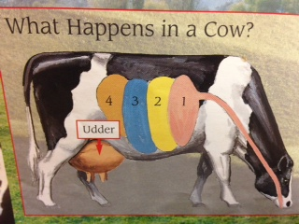

RI 2.8 Describe how reasons support specific points the author makes in a text.

What claim is the author making about cows?

What evidence does the author use to support her claim?

List text evidence found in the text: