Summative Assessment for

2nd Grade

Unit 5

Narrative Writing and Reading Point of View

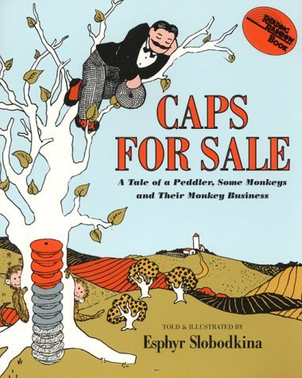

Materials:

The book Caps for Sale (read aloud)

1 copy of the student page per student

(to be completed independently)

Student Friendly Rubric

Teacher Recording Page

Optional: planner or graphic organizer

Say to students:

“You have listened to the story Caps for Sale. Think about how the story would be different if it were told from monkey’s point of view.

Put yourself in the monkey’s place and write a narrative story retelling the story from the monkey’s point of view. Be sure to include details from the passage.”

Read the directions at the top of the student page and give students approximately 30-45 minutes to complete.

Name: _______________________________

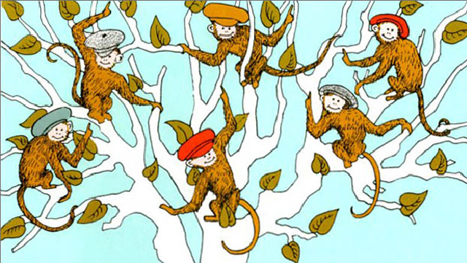

Date: ___________

Narrative Writing (W.2.3 & RL.2.6)

1. Think about how the story might be different if one of the monkeys told the story.
2. Put yourself in the monkey’s place.
3. Plan and write a new story. Be sure to use details from the passage.

____________________________________________________________________________________________________________________________________________________________________________________________________________________________________________________________________________________________________________________________________________________________________________________________________________________________________________________________________________________________________________________________________________________

Rubric for Narrative/Point of View Task Teacher: ________

Unit 5

|  |  |  |  |  |  |  |  |  |
| --- | --- | --- | --- | --- | --- | --- | --- | --- |
|  | W.2.3 Writes a narrative | | | | | | | RL.2.6 Point of View |
| Name | Recountsan event | Include details to describe | Actions | Thoughts | Feelings | Temporal words | Sense of closure | Writes from monkey’s point of view |
|  |  |  |  |  |  |  |  |  |
|  |  |  |  |  |  |  |  |  |
|  |  |  |  |  |  |  |  |  |
|  |  |  |  |  |  |  |  |  |
|  |  |  |  |  |  |  |  |  |
|  |  |  |  |  |  |  |  |  |
|  |  |  |  |  |  |  |  |  |
|  |  |  |  |  |  |  |  |  |
|  |  |  |  |  |  |  |  |  |
|  |  |  |  |  |  |  |  |  |
|  |  |  |  |  |  |  |  |  |
|  |  |  |  |  |  |  |  |  |
|  |  |  |  |  |  |  |  |  |
|  |  |  |  |  |  |  |  |  |
|  |  |  |  |  |  |  |  |  |
|  |  |  |  |  |  |  |  |  |
|  |  |  |  |  |  |  |  |  |
|  |  |  |  |  |  |  |  |  |
|  |  |  |  |  |  |  |  |  |
|  |  |  |  |  |  |  |  |  |
|  |  |  |  |  |  |  |  |  |
|  |  |  |  |  |  |  |  |  |
|  |  |  |  |  |  |  |  |  |
|  |  |  |  |  |  |  |  |  |
|  |  |  |  |  |  |  |  |  |

Student: _______________________________________

Rubric for Narrative & Point of View Task

|  |  |  |  |  |
| --- | --- | --- | --- | --- |
|  | 4 | 3 | 2 | 1 |
| Writes a narrative in you recount an event | My story is written in sequence and includes all events. | My story is written in sequence and includes most of the events. | My story is written mostly in sequence and includes some events. | My story includes only some events. |
| Includes details like thoughts, actions, and feelings of characters | I included details about thoughts, feelings, and actions of the monkey. | I included details about actions, thoughts, or feelings. | I included some details. | I included a few details. |
| Uses temporal words | I used phrases like “after the dog went to the store” to signal changes in time. | I use words like “then”, “after that”, or “during” to signal changes in time. | I used words like “first”, “next”, “then”, and “last” to signal changes in time. | I used no words to signal changes in time. |
| Provides a sense of closure | My story has a strong concluding sentence. | My story has a sense of closure. (The reader knows that the story is over.) | My story has a sense of closure. (The reader may not know the story is over.) | My story has no sense of closure. |
| Writes from monkey’s point of view | I told the story like I’m the monkey the whole time. | I told the story like I’m the monkey most of the time. | I told the story like I’m the monkey some of the time. | I did not tell the story like I’m the monkey. |