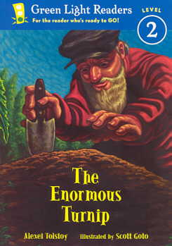**The Enormous Turnip**

**RL.2.2 Recount Stories, including fables and folktales from**

**diverse cultures, and determine their central message, lesson,**

**or moral.**

The students read The Enormous Turnip with partners. The partners

worked together to complete the graphic organizer. They recalled the characters, setting, the events in the story, and discussed the lesson of the story.

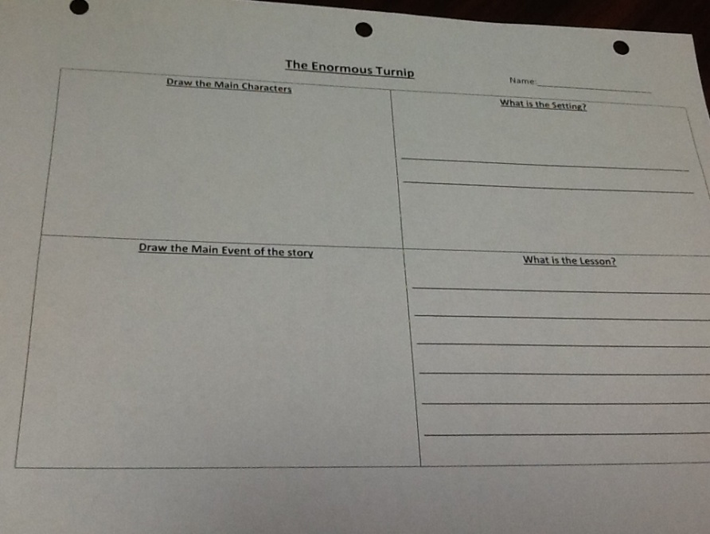

The next day the teacher reread the book to the class. Students then independently completed the lesson they learned from reading The Enormous Turnip.

