Stone Soup by Jon J. Muth

Name________________________

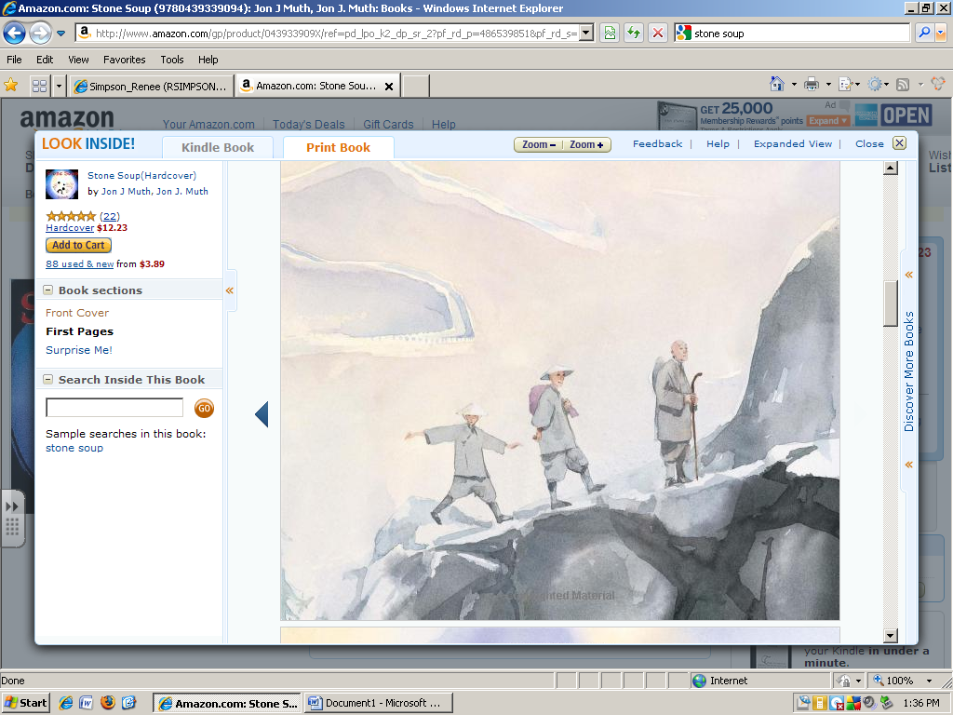

The men are ____________ in the mountains.

hiking sitting leaning dancing

The second man is carrying a ____________.

stick bundle hat rock

The mountain is very ______________.

steak low steep slow

An exciting experience is a/an…

climb movie concert adventure