|  |  |  |  |
| --- | --- | --- | --- |
| **One Week’s Food in May** | | | |
| **Grains & Starchy Foods**   * potatoes * white rice * basbousa powder * macaroni * pita bread * gullash | **Dairy**   * milk powder * butter * white cheese salted * white cheese unsalted * Italian cheese * *President* cheese * yogurt | **Meat, Fish & Eggs**   * farm chickens * lamb meat * eggs * canned tuna * beef burger patties * frozen beef * corned beef * pickled meat | **Fruits, Vegetables & Nuts**   * watermelons * yellow bananas * peaches * white eggplants * red onions * tomatoes * green olives mixed with lemons * green peppers * squash * black olives * cucumbers * garlic * grape leaves * Jew’s melon * okra * beans * pickled vegetables |
| **Condiments**   * sunflower oil * sugar * file spices * honey * cilantro * parsley * black pepper * chili powder * coriander seed * cumin * mixed spices * salt | **Snacks**   * Halawa (sweet sesame cake) | **Prepared Food**   * cooked beans | **Beverages**   * *Coca-cola* * orange soda * *Sprite* * tea * tap water |

**The Ahmeds of Cairo, Egypt**

From Hungry Planet by Peter Menzel and Faith D’Aluisio

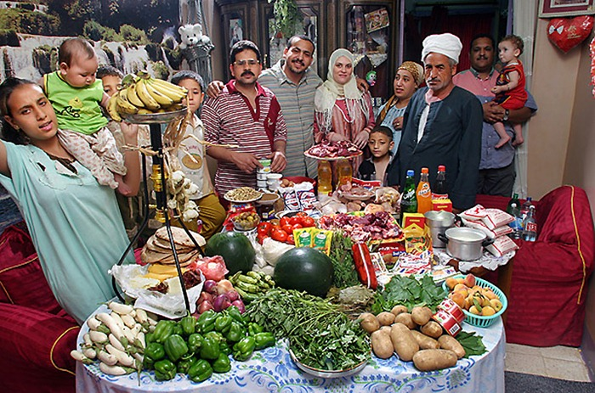

**The Casaleses of Cuernavaca, Mexico**

From Hungry Planet by Peter Menzel and Faith D’Aluisio

|  |  |  |  |
| --- | --- | --- | --- |
| **One Week’s Food in May** | | | |
| **Grains & Starchy Foods**   * corn tortillas * rolls * white rice * potatoes * white bread * *Special K* cereal * pasta * pan dulces * bread sticks | **Dairy**   * whole milk * sour cream * ice cream pops * yogurt * handmade cheese * evaporated milk * Manchego cheese * cream cheese * butter | **Meat, Fish & Eggs**   * chicken pieces * eggs * tilapia (fish) * catfish * sausage | **Fruits, Vegetables & Nuts**   * mangos * pineapples * watermelon * oranges * cantaloupe * guavas * quinces * yellow bananas * roma tomatoes * tomatillos * corn * avocados * chayote squash * beans * white onions * zucchini * pickled jalapenos * green beans * fresh jalapenos * broccoli * garlic * chipotle peppers |
| **Beverages** |
| **Condiments**   * canola oil * margarine * mayonnaise * salt * garlic salt * black pepper * cumin bay leaves | **Snacks & Desserts**   * lollipops * chocolate candy * *Gamesa* crackers * marshmallows * chili candy | **Prepared Foods**   * mole sauce * chicken bullion | **Beverages**   * *Coca-Cola* * bottled water * beer * juice * *Gatorade* * instant coffee |

