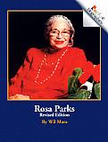Use what you have learned to write a narrative to explain how Rosa Parks changed history.

Be sure to include:

* details to describe actions, thoughts and feelings
* words to signal event order
* a sense of closure

